Srping REST API and Services

- create REST API/web service with spring

-REst Consepts JSON and HTTP messaging

- REST client tool postman

-Deveolp REST API with @RestController

-CRUD inteface through SPRING REST

Bussiness Problem

-Build Cleint app that provides wheather report to city

- need to get dat from external seervices

Application A/c

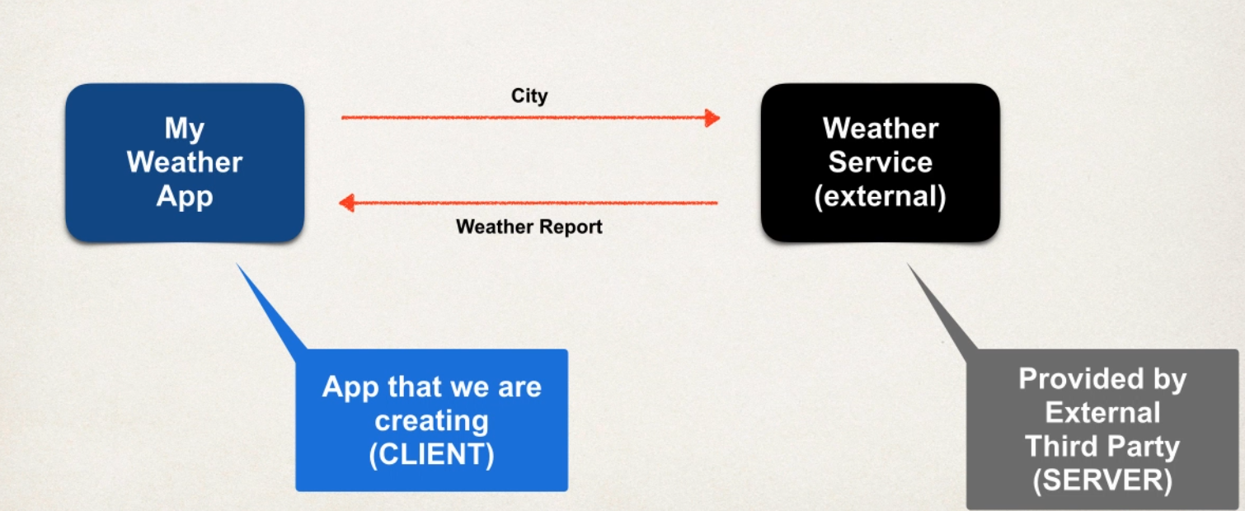

Question

1 how we connect to wheather service

2 whcih lang to use

3 data format

Ans:

1 we can use rest API call over http

REST: REpresentational State Transfer

Light weight approcah to communicate between 2 applications

2 Rest is lang independent

-client can use any prog lang and server can use any prog lang

3 Rest app can use any data format common used XML and JSON. JSON is most commonly used

JSON: Java SCript Object Notation

Solution

Free wheather service by openweathermap.org

Call wheather service API doucmnetion gives

By passing city name:

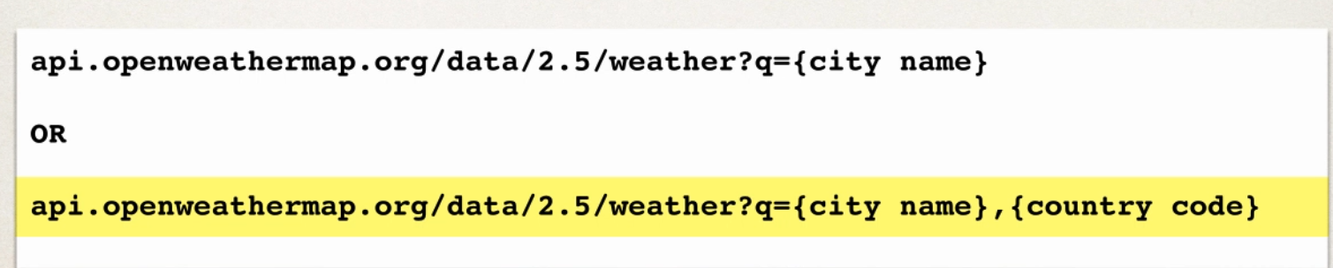

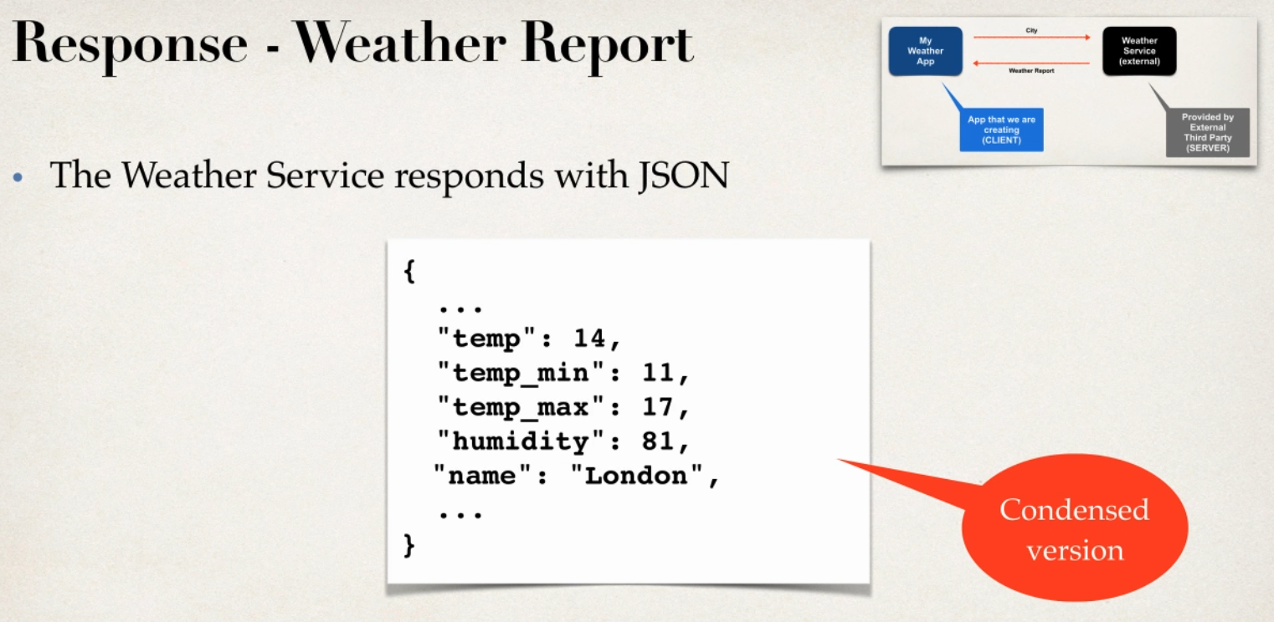

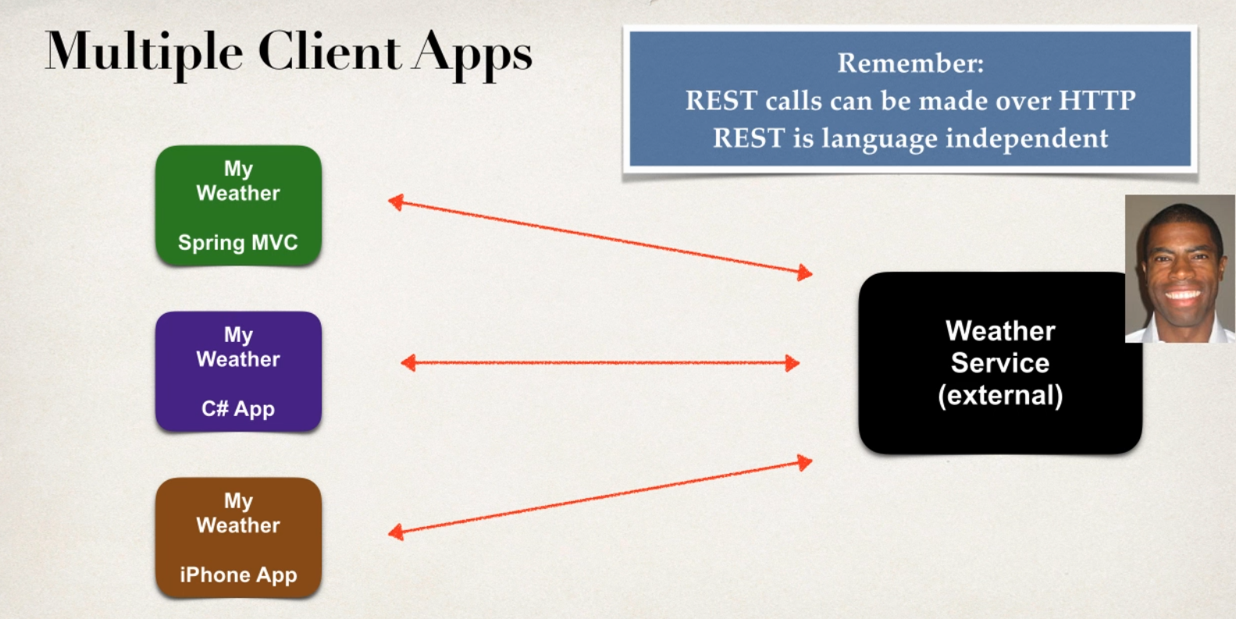

Simlar Apps like currney converter app

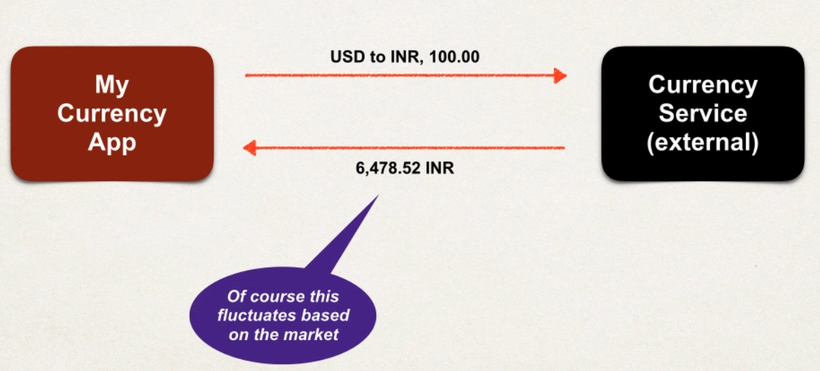

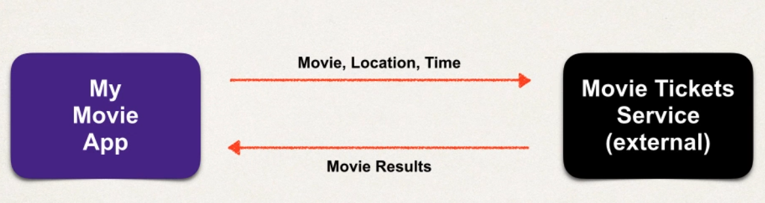

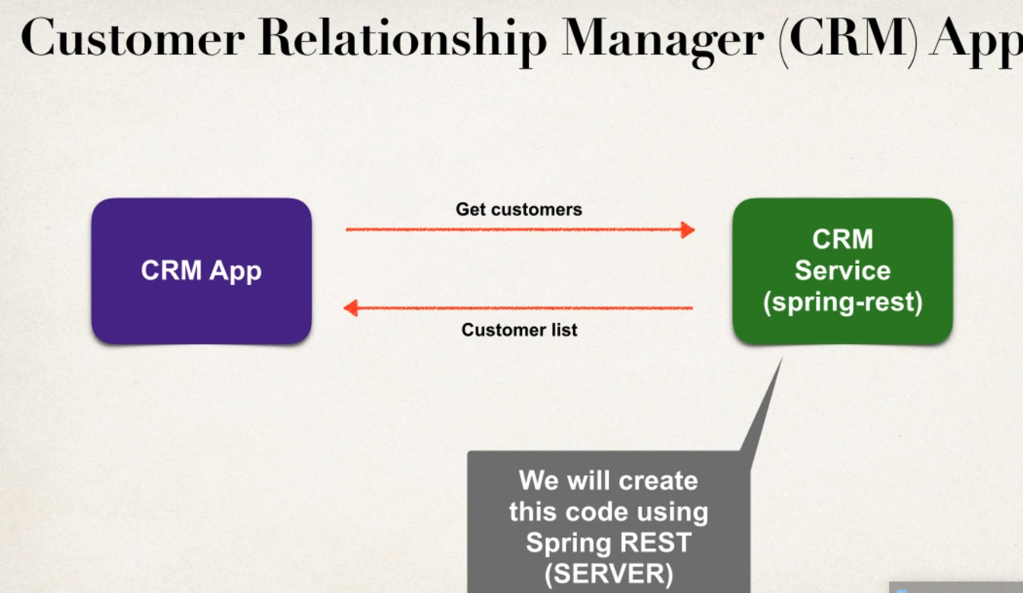

Ex Saleforce Platform API

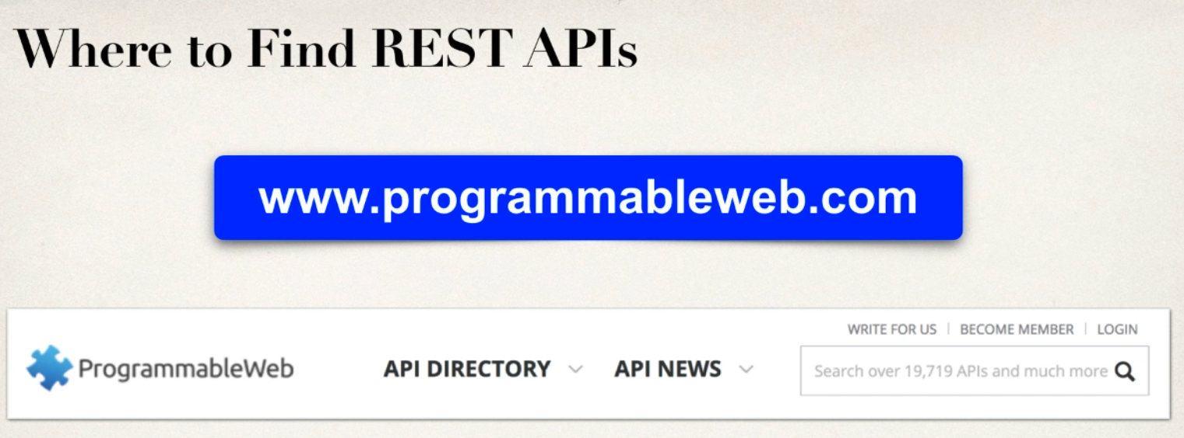

JSON OVERVIEW

BASICS

-JAVA script Object Notation

-Light weight dat format for storing and exchanging data plain text

-lang independent.. not just only for java script can be used with any prog lang

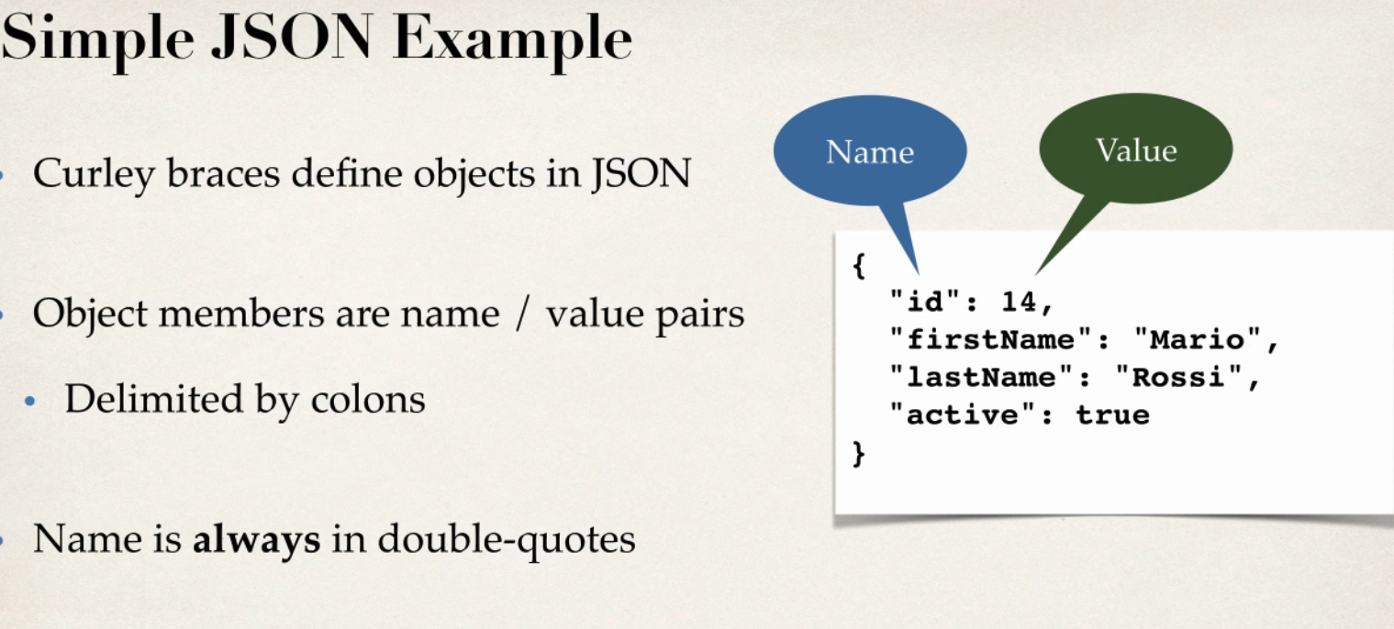

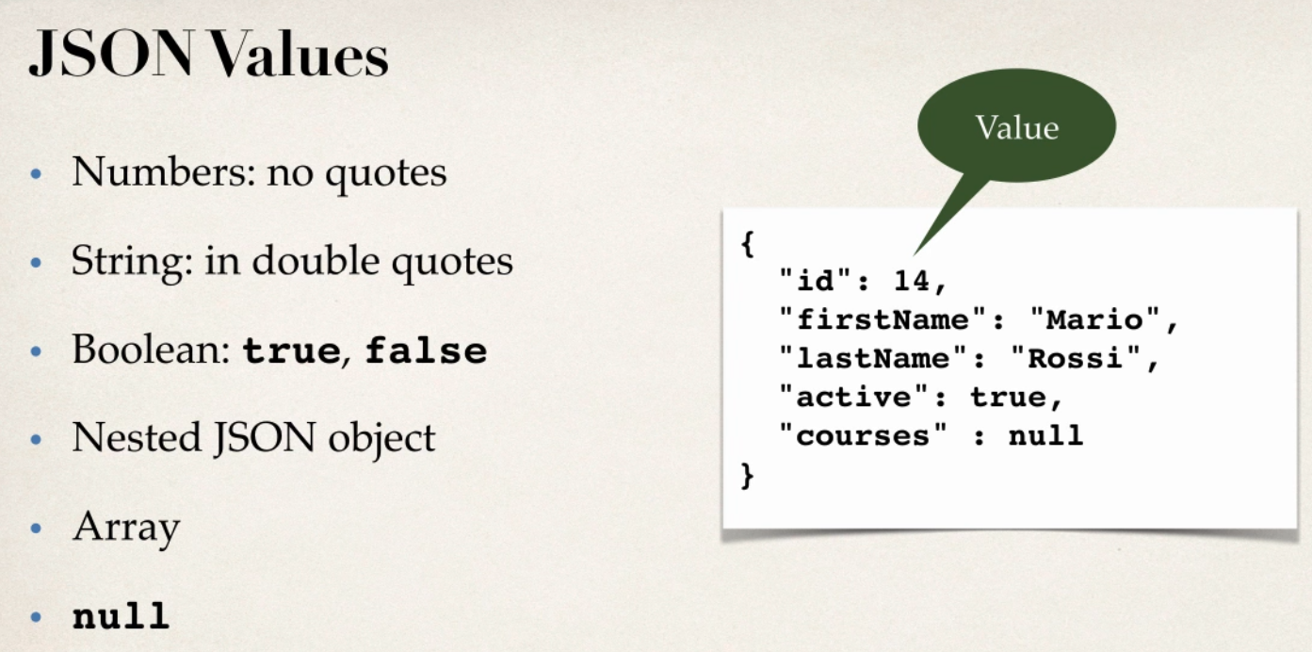

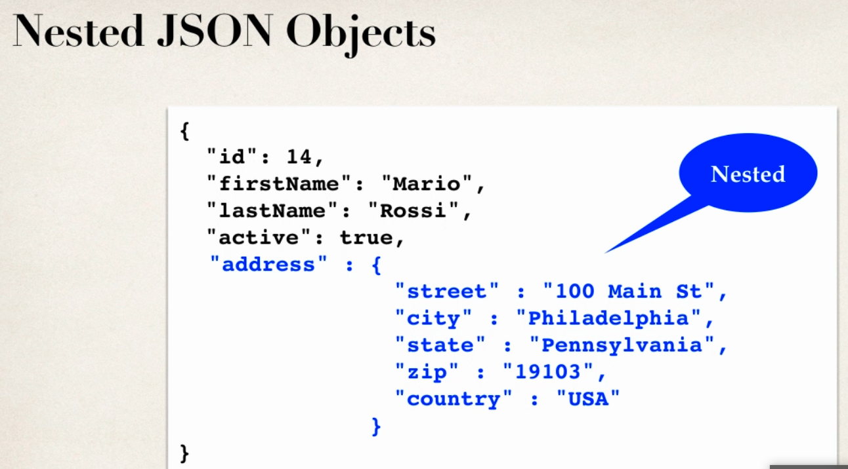

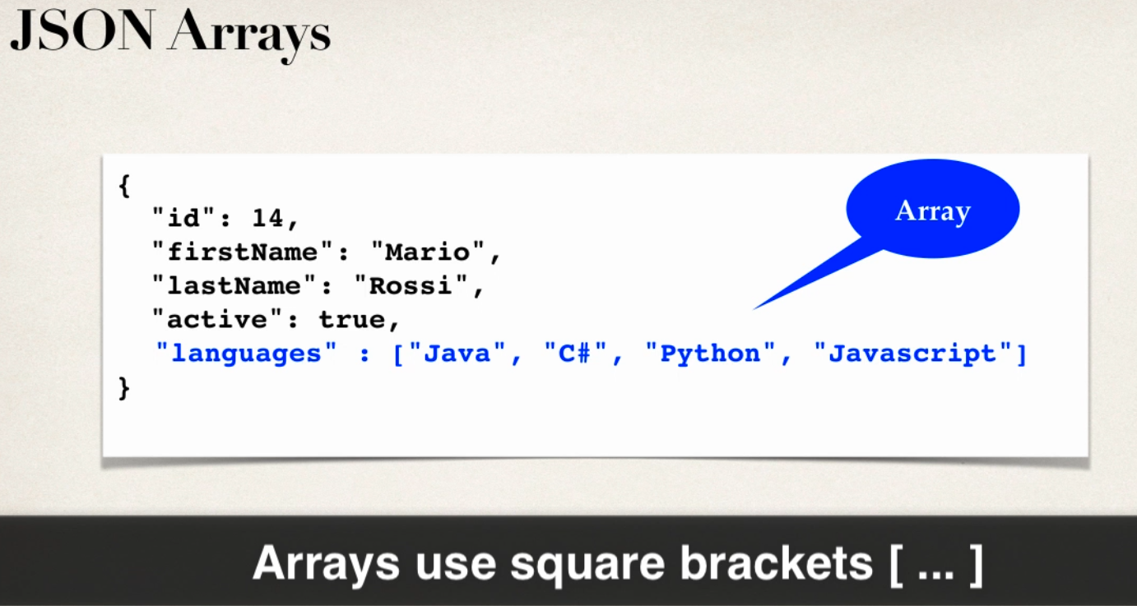

JAVA JSON DATA BINDING

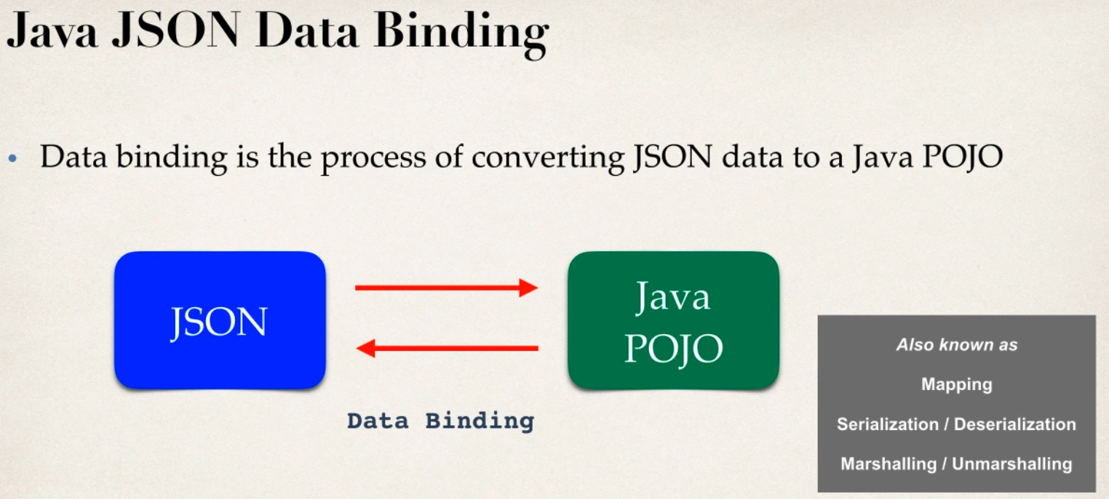

JSON data binding with jackson

- spring uses jackson project behind scene

- jackson handle data binding between json and java pojo

- jackson is separate project



JACKSON DATA BINDING

- jackson data binding API

Pkg: com.fasterxml.jackson.databind

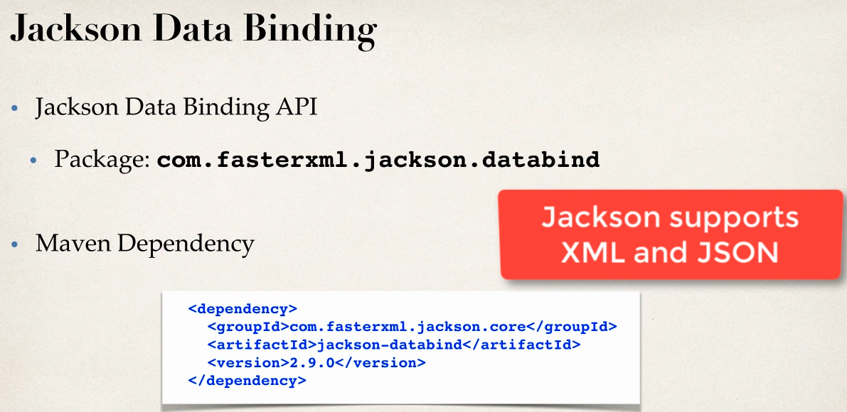

- by default jackson will call appropricate getter and setter method

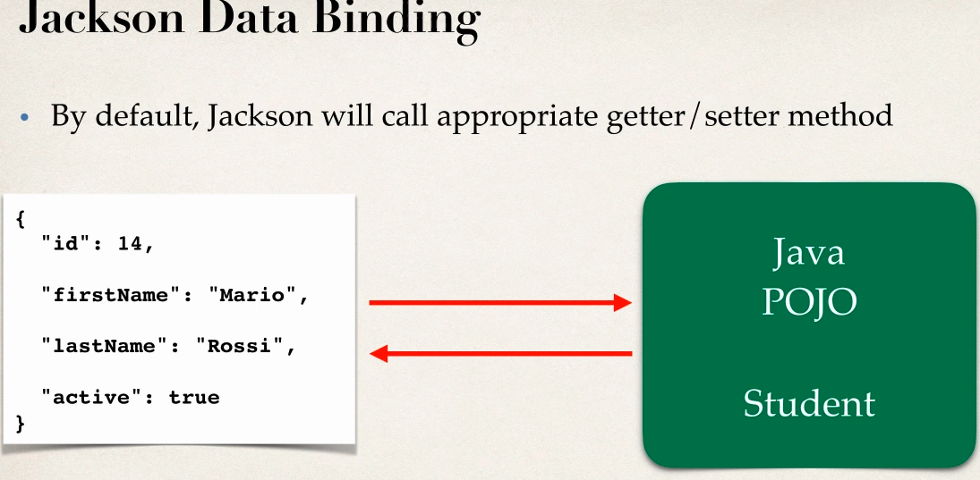

JSON TO JAVA POJO

- convert json to java pojo call settter methods on POJO

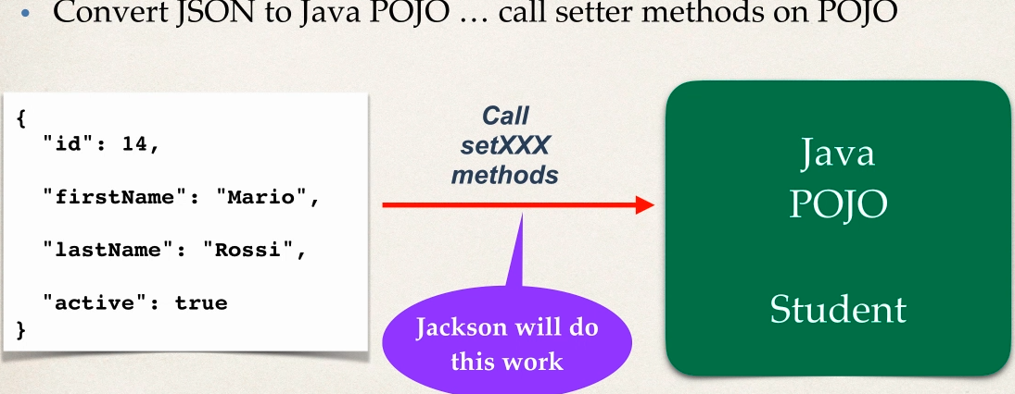

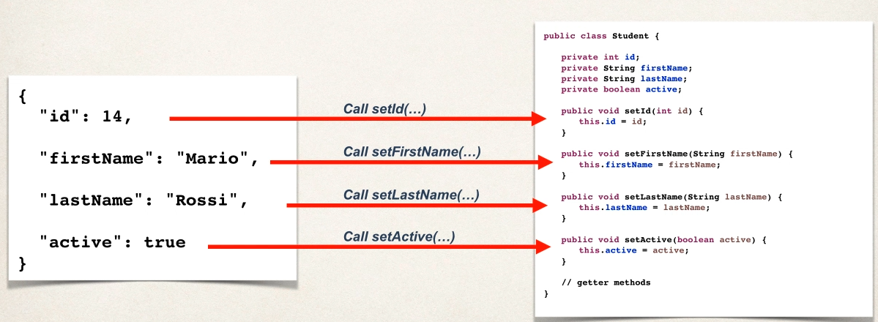

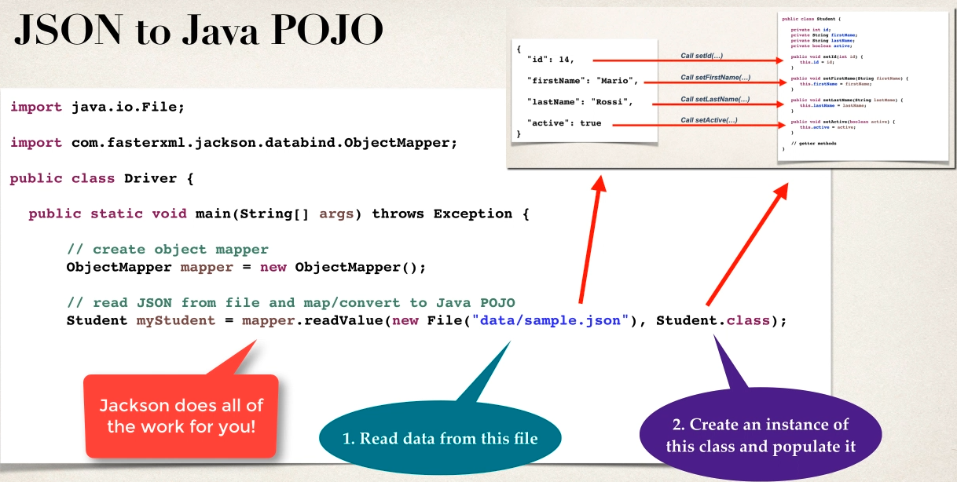

JAVA POJO TO JSON

-convert java pojo to json call getter methods on pojo

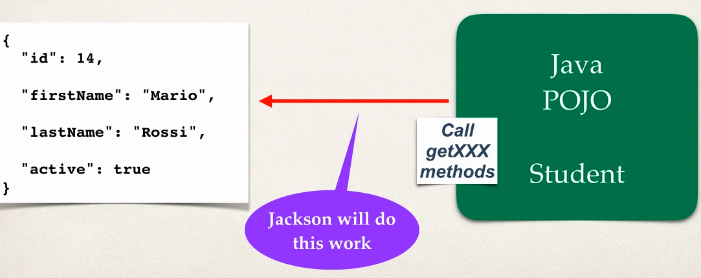

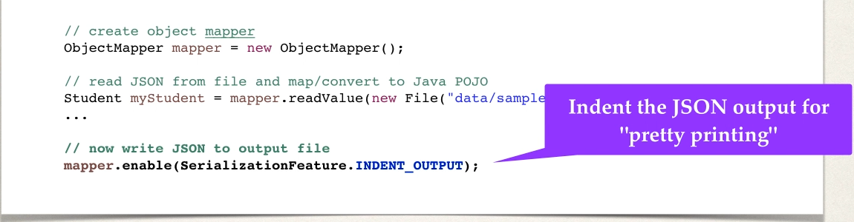

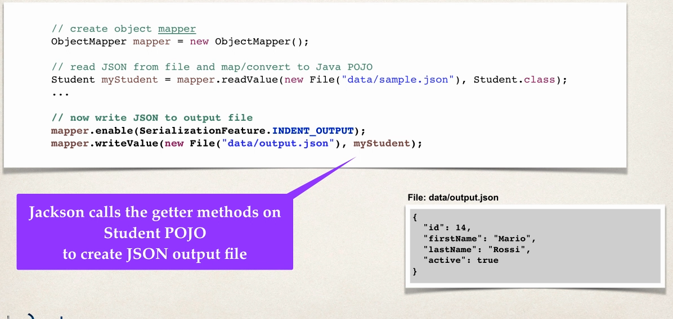

SPRING and JACKSON support

- in Spring REST appplications

- spirng will automatically handle jackson integration

- json data binding passed to REST controller is coneverted to pojo

- java object being returned from REST controller is converted to json usgin JACKSON

- all handled in backgrounf automatically

Converting JSON to JAVA POJO

Development Process

1 download and import starter files

2 add maven dependnecy for jackson project

3 create Student POJO class

4 create main driver app

Step 2

<!-- https://mvnrepository.com/artifact/com.fasterxml.jackson.core/jackson-databind -->

<dependency>

<groupId>com.fasterxml.jackson.core</groupId>

<artifactId>jackson-databind</artifactId>

<version>2.10.3</version>

</dependency>

Step 3

public class Student {

private int id;

private String firstName;

private String lastName;

private boolean active;

}

Step 4

public class DriverMainApp {

public static void main(String[] args) {

try

{

// create Object mapper

ObjectMapper mapper=new ObjectMapper();

// read json file and map/convert to java POJO :data/sample-lite.json

//Student student=mapper.readValue(new File("data/sample-lite.json"), Student.class);

Student student=mapper.readValue(new File("data/sample-full.json"), Student.class);

// print data of pojo

System.err.println("First Name ==>>"+student.getFirstName());

System.err.println("Last Name ==>>"+student.getLastName());

}

catch (Exception e) {

e.printStackTrace();

}

}

simple-lite.json

{

"id":14,

"firstName":***"sachin"***,

"lastName":***"gowda"***,

"active":true

}

WORKS with simple student entity

With simple-full.json

{

"id":14,

"firstName":***"sachin"***,

"lastName":***"gowda"***,

"active":true,

"address": {

"street":***"seeghali main road"***,

"city":***"Bangalore"***,

"state":***"karnataka"***,

"zip":***"573201"***,

"country":***"india"***

},

"languages":[***"English"***,***"Hindi"***,***"kannada"***]

}

Check this will get eception for above json since there is no setters for address and jackson always looks for setter method whos key in json file

com.fasterxml.jackson.databind.exc.UnrecognizedPropertyException: Unrecognized field "address" (class com.spring.restjacson.SpringRestJacksonDemo.Student), not marked as ignorable (4 known properties: "lastName", "id", "active", "firstName"])

Solution create a Nested class Address since it is an json object in json object

Address Entity

public class Address {

private String street;

private String city;

private String state;

private String zip;

private String country;

}

MAIN APP

Student student=mapper.readValue(new File("data/sample-full.json"), Student.class);

// print data of pojo of Student class

System.err.println("First Name ==>>"+student.getFirstName());

System.err.println("Last Name ==>>"+student.getLastName());

// print data of pojo of Address class

System.err.println("City Name ==>>"+student.getAddress().getCity());

System.err.println("State Name ==>>"+student.getAddress().getState());

// print data of pojo of Student class

System.err.println("Languages ==>>"+Arrays.toString(student.getLanguages()));

-IF JSON HAS property you dnt care about wouldnt be great to ignore it

USE CASE

- new proprty added to json our code is not aware of it so it will cause exception

-modify code to ignore properties

- add one more property in json file dnt add in java entity

-add this below line will ignore the proerty and Exception will be avoided

@JsonIgnoreProperties(ignoreUnknown=true)

public class Student

REST HTTP Basics

- most common use of REST is over HTTP

- leverage HTTP methods for CRUD operations

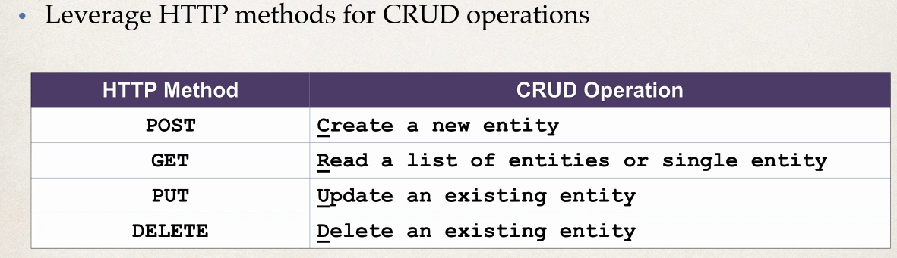

HTTP Messages

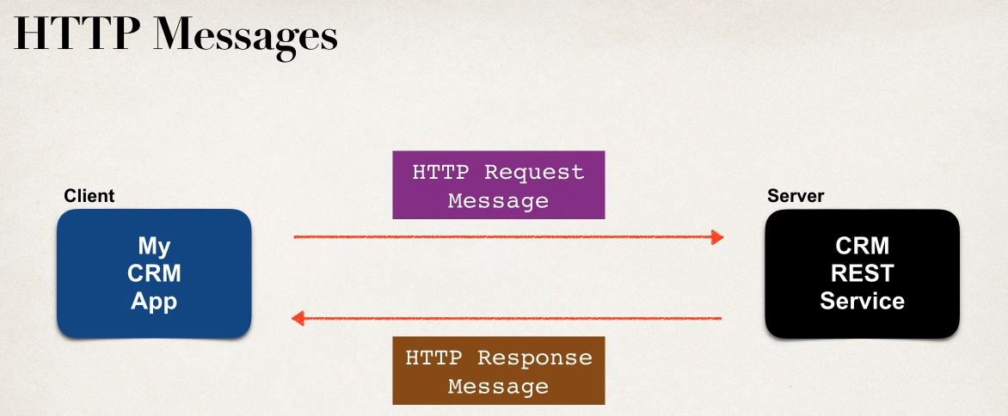

HTTP Request Message

1 Request Line: the http command GET,POST,PUT,DELETE

2 Header Variables: request metadata

3Message Body : contents of message/payload like entity will be in the msg body as json

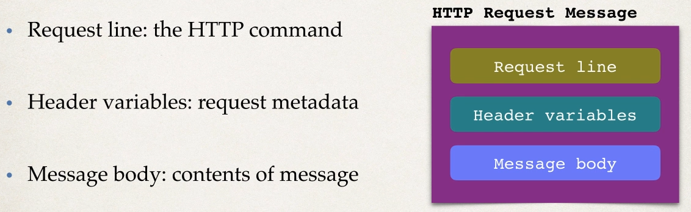

HTTP Response Message

1 Response Line : server protocol and status code like ststus code like http status code :200,500,404

2 Header variables : repsponse metadata

3 message body : contents of message body like xml or json

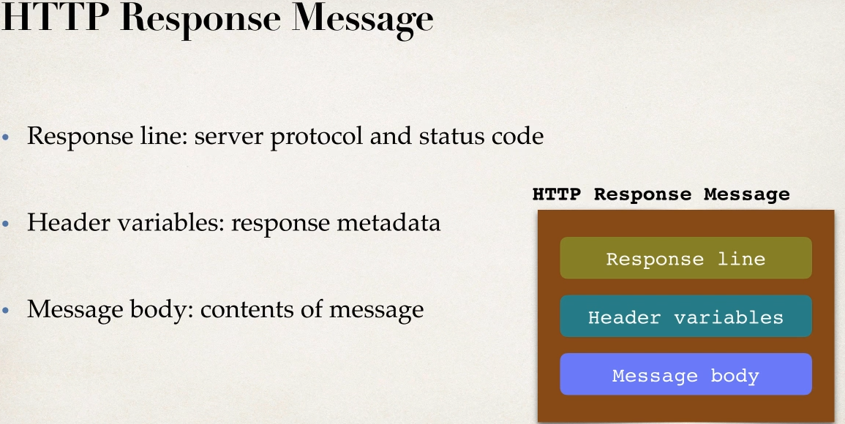

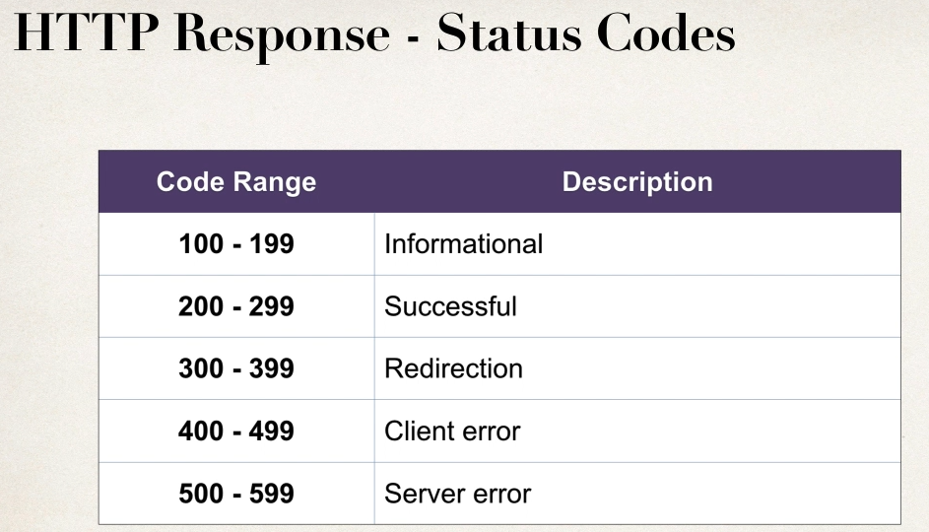

MIME Content Types

-message format is described by MIME content type

-Multipurpose Internet Mail-Extension

Syntax

Basic : type/sub-type

Example

text/html,text/plain

application/json,application/xml

Client Tool

To send HTTP request to the WEB service /API

Tools like curl,postman

Use this to chck online test REST API

Use it with postman

<http://www.jsontest.com/>

-provides a collections of backend REST services to test against

Ex call

1 API to get IP

http reg : <http://ip.jsontest.com/>

Response : {"ip": "106.206.15.16"}

2 API for Date

<http://date.jsontest.com/>

{

"date": "04-23-2020",

"milliseconds_since_epoch": 1587632213288,

"time": "08:56:53 AM"

}

Fake Online REST API for Testing and Prototyping

<http://jsonplaceholder.typicode.com/>

Try API like

<http://jsonplaceholder.typicode.com/users>

SPRING REST Controller

-spring MVC provide support for Spring REST

-new Annontaion @RestController

-Extension of @Controller

-Handles REST request and response

-Spring REST will also automatically convert java pojo to json

- as long as we have jackson project in project

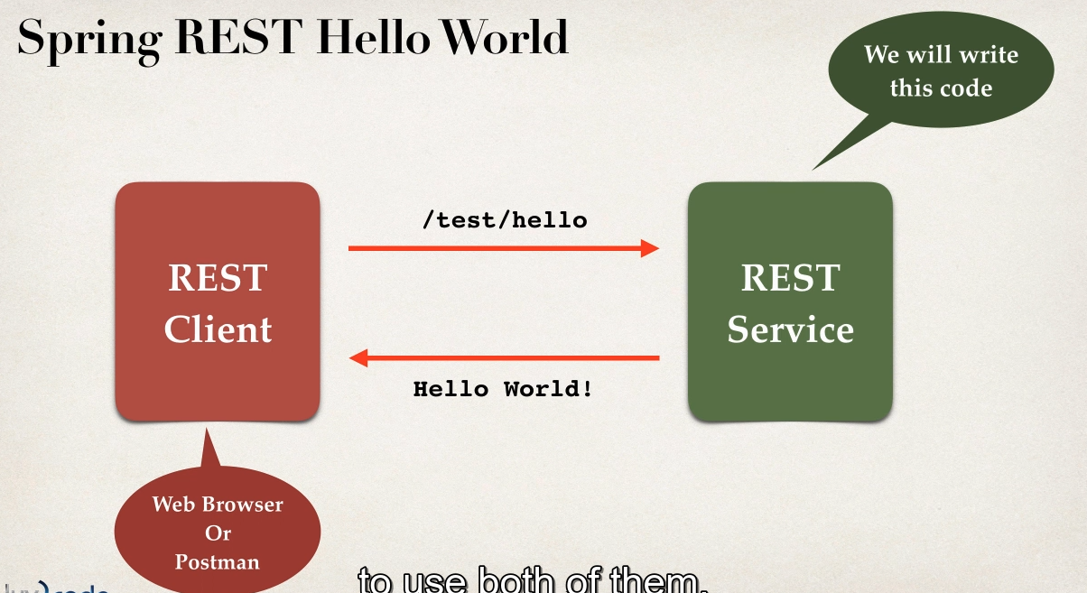

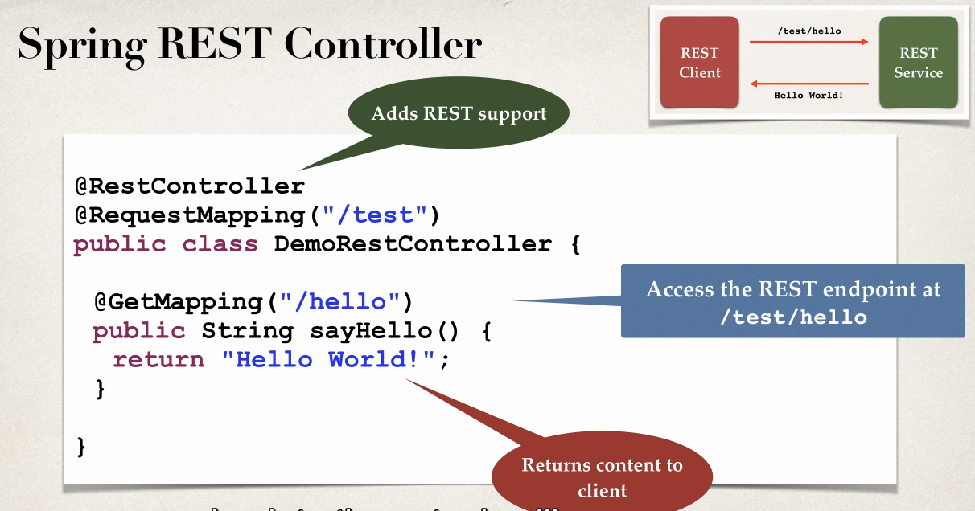

WEB BROWSER VS POSTMAN

-for simple Simple REST testing for GET req

-web browser and postman are similar

- For advanced REST testing PSOT,PUT etc POSTMAN will be much support

-posting json data ,setting content type

-passing HTTP req headers,authentication etc

Development Process

1 add maven dependency for Spring MVC and JACKSON

2 Add code for all Java COnfig : @Configuration

3 Add code for all JAva config : Servlet Intializer

4 create Spring REST service using @RestController

Spring REST API STUDENT Class

- return list of students

GET

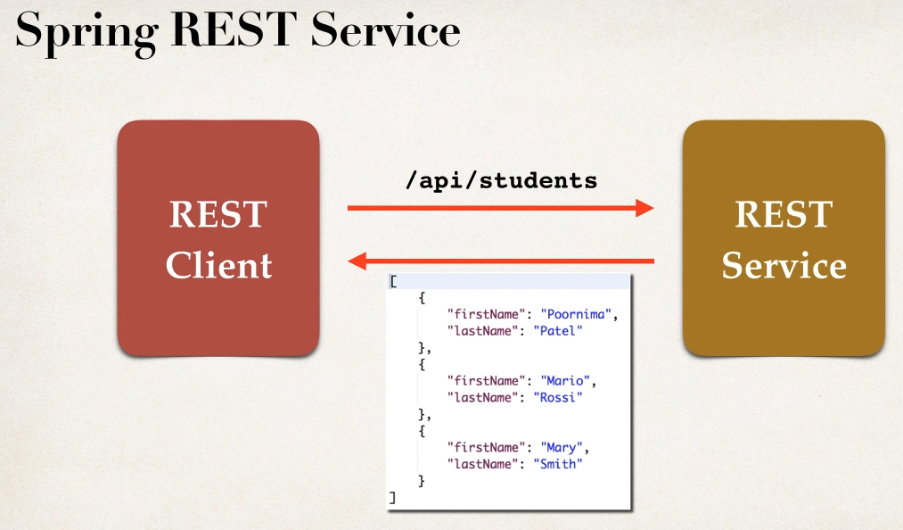

Convert POJO JAVA to JSON

-REST will retrun List<Student>

- need to convert List<Student> to JSON

- jackson will handle

Spring and Jackson support

-spring will handle jackson integration

-JSON data being passed to REST controller is converted to JAVA POJO

-JAva POJO being returned from REST controller is converted into JSON

1 Create Class

Student

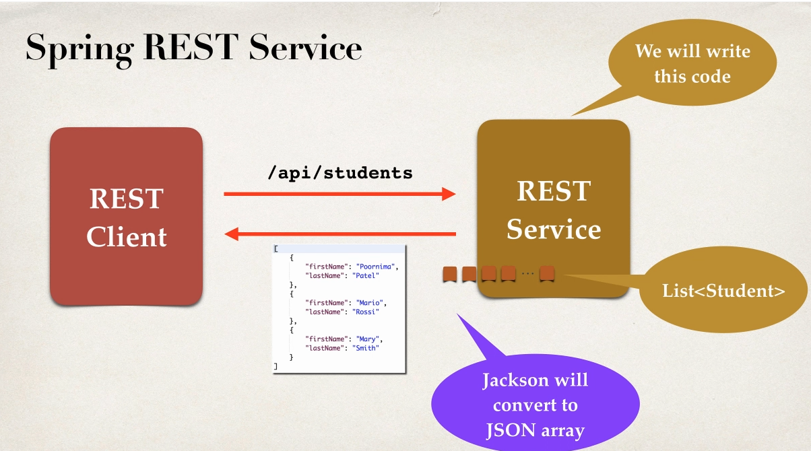

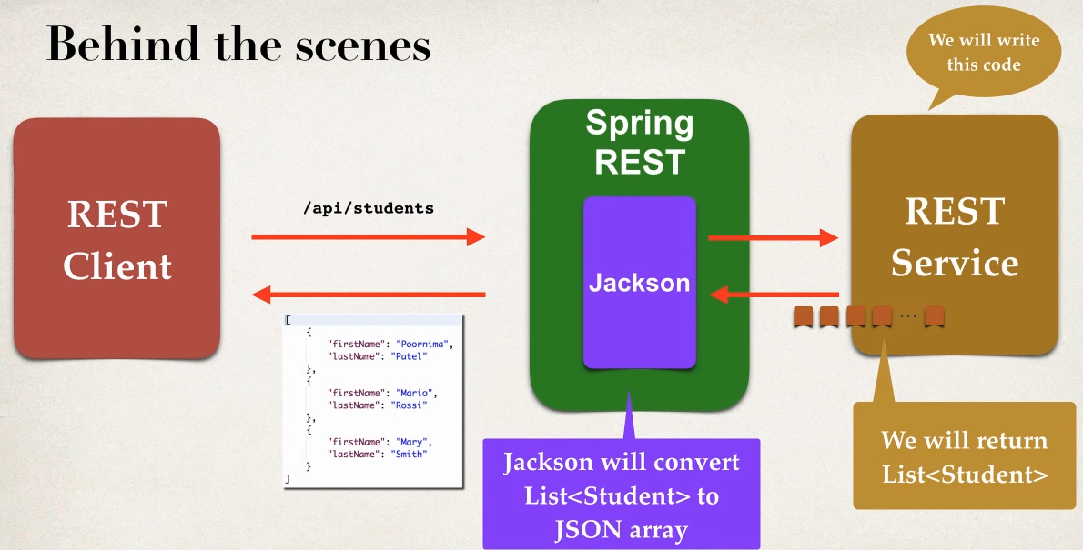

Development Process

1 create Java POJO class Student

2 Create Spring REST service using @RestController

public class Student {

private String firstName;

private String lastName;

public Student() {

}

public Student(String firstName, String lastName) {

super();

this.firstName = firstName;

this.lastName = lastName;

}}

@RestController

@RequestMapping("/api")

public class StudentDemoController {

//define end point for /students return list of student

@GetMapping("/students")

public List<Student> getStudents()

{

List<Student> students=new ArrayList<>();

students.add(new Student("sachin", "gowda"));

students.add(new Student("darshan", "gowda"));

students.add(new Student("manasa", "gowda"));

return students;

}

}

Use ?in end of URL to avoid cached data from browser. It will give real time data if its taking cache data

<http://localhost:7777/SpringRestAPIDemo/api/students?>

Spring REST with PATH Variable

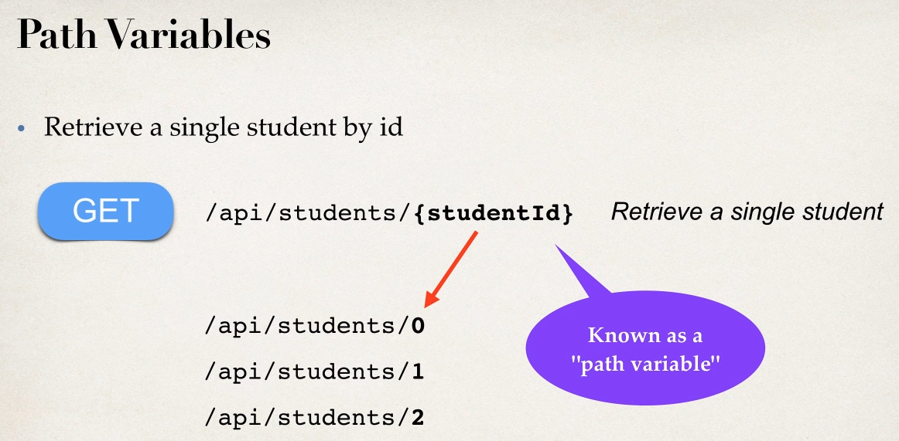

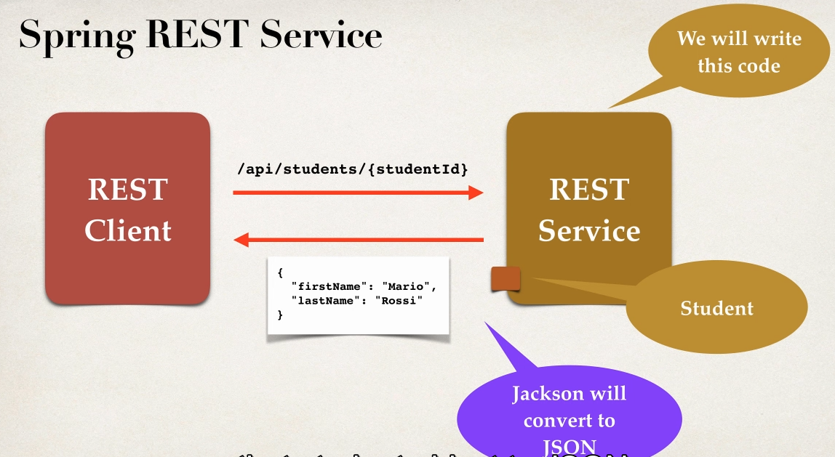

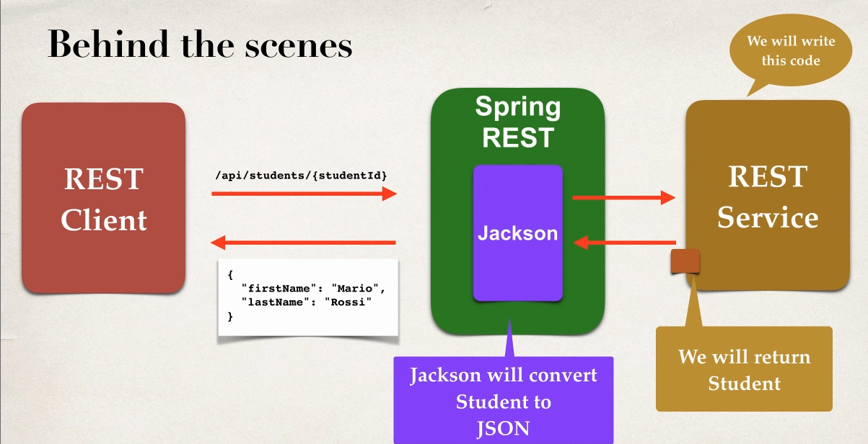

Development Process

1 Add Request mapping to Spring REST Service

Bind path variable to method parameter using @pathvariable

Step 1

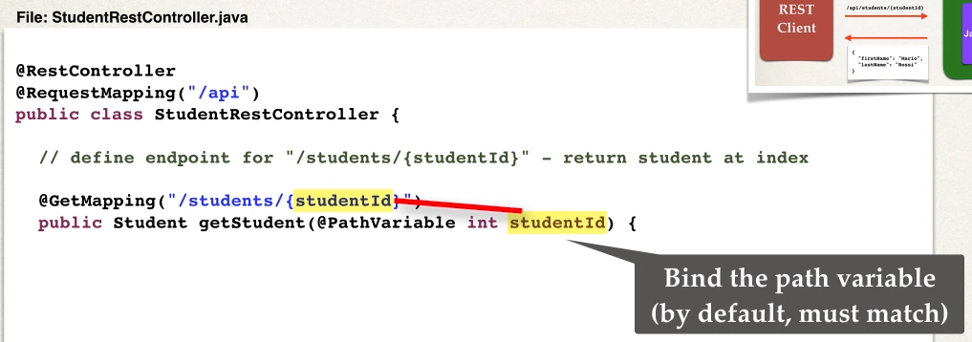

@RestController

@RequestMapping("/api")

public class StudentDemoController {

private List<Student> students;

// Define @PostConstructor to load the Student data only once

@PostConstruct

public void loadData()

{

students=new ArrayList<>();

students.add(new Student("sachin", "gowda"));

students.add(new Student("darshan", "gowda"));

students.add(new Student("manasa", "gowda"));

}

//define end point for /students return list of student

@GetMapping("/students")

public List<Student> getStudents()

{

// data is alredy been lodaed bcz of @PostConstruct

return students;

}

// define end point for /students/{studentId} retrun student at index

@GetMapping("/student/{studentId}")

public Student getStudent(@PathVariable int studentId)

{

// by default variable should match

// data is alredy been lodaed bcz of @PostConstruct

return students.get(studentId);

}

}

Result of using PATH VARIABLE

<http://localhost:7777/SpringRestAPIDemo/api/student/1> data in index 1

<http://localhost:7777/SpringRestAPIDemo/api/student/9> will give error 500 response since array out of bound

Spring REST Exception HANDLING

- we don’t want show error of html as a response so need to handle

-handle the exception retrun error in JSON

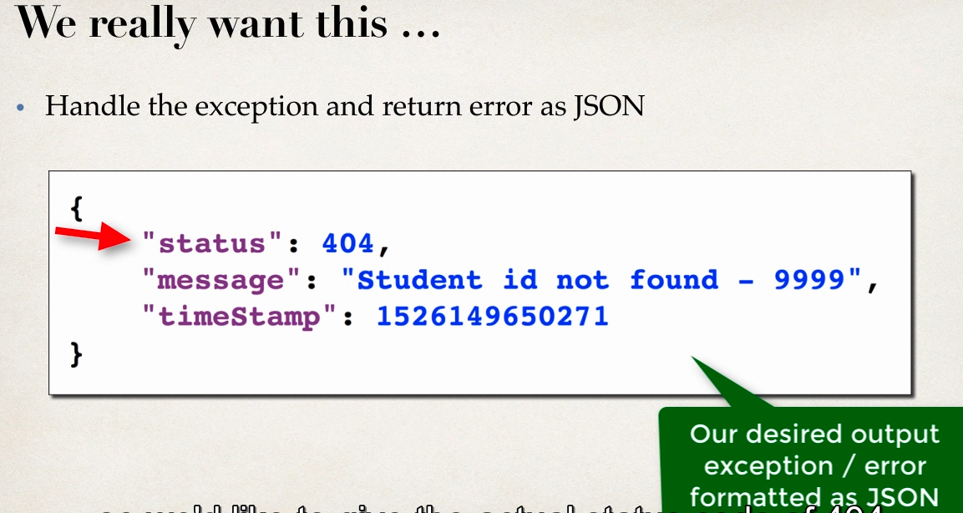

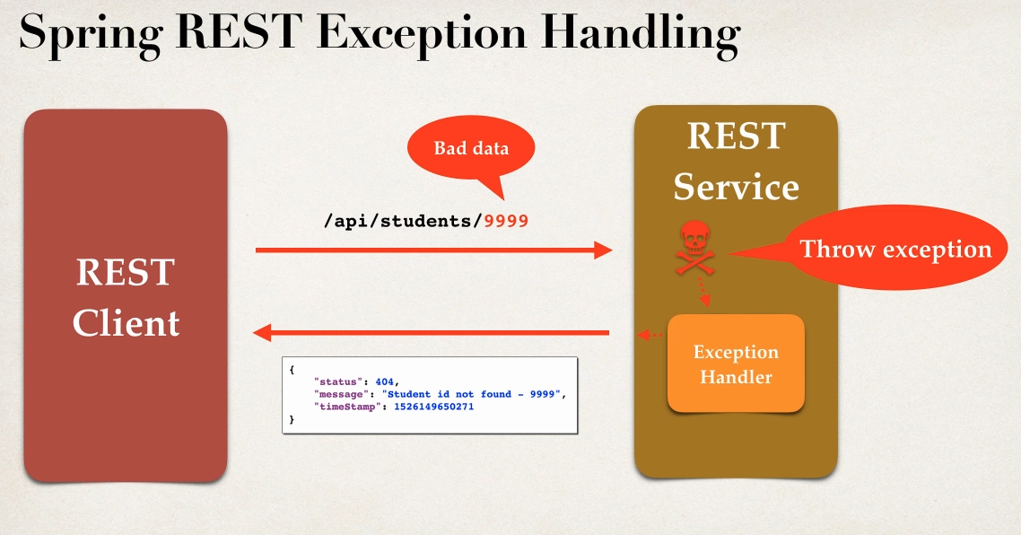

Development Process

1 create custome error response code

2 create custom exception class

3 update the REST service to through exception if student not found

4 Add exceptional Handler Method using @ExceptionHnadler

Step 1

-Create Custom error response class

-custom error response wil be sent back to cleint as json

- will define as java class (POJO)

-jackson will handle converting it so json

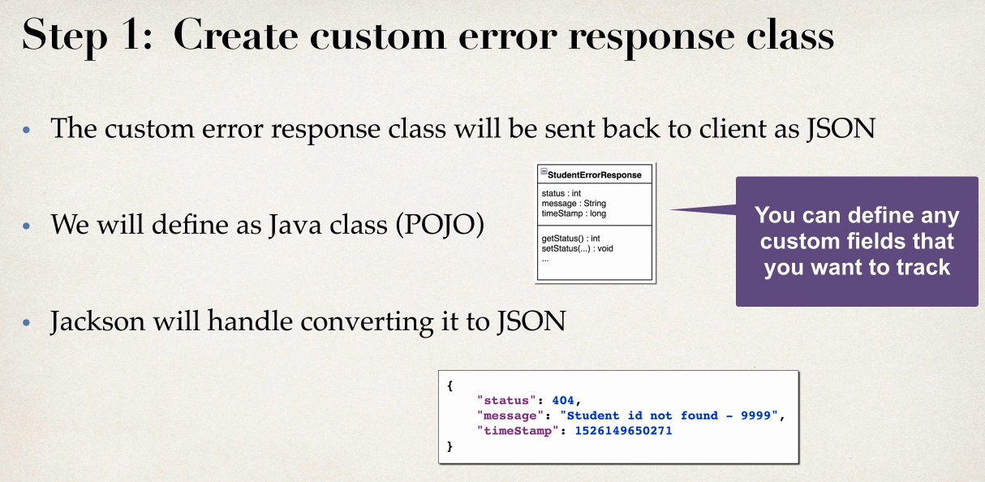

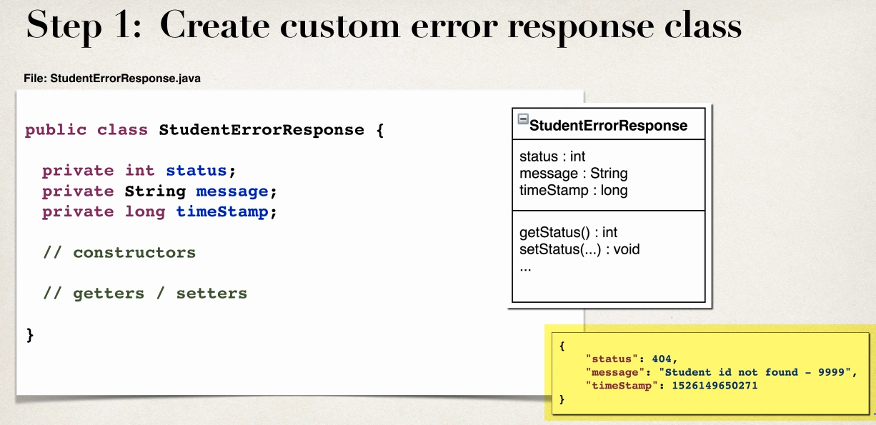

public class StudentErrorResponse {

private int status;

private String message;

private long timeStamp;

public StudentErrorResponse() {

}

public StudentErrorResponse(int status, String message, long timeStamp) {

this.status = status;

this.message = message;

this.timeStamp = timeStamp;

}

}

Step 2 create custom student Exception

- the custom student exception will used by our REST service

- in code if student cant be find then we’ll throw exceptions

- need to define custom Student exception class

-StudentNotFoundException

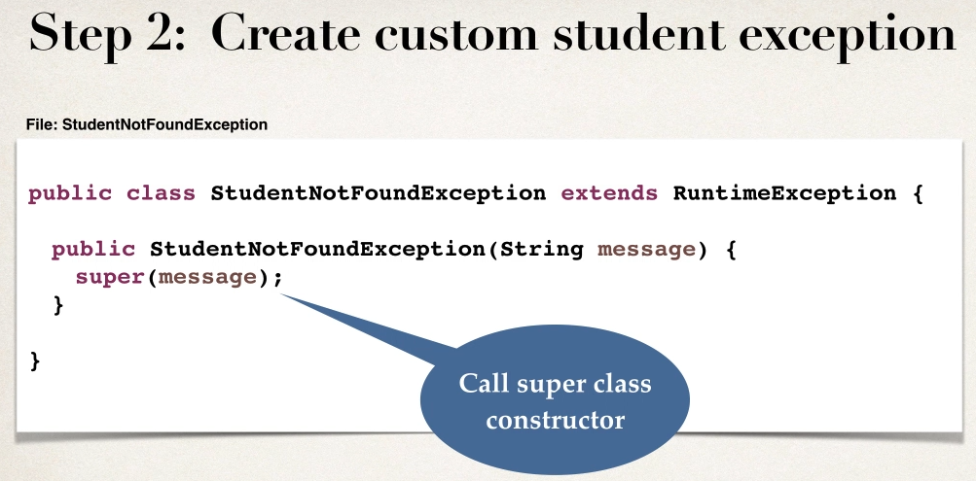

public class StudentNotFoundException extends RuntimeException {

public StudentNotFoundException(String message, Throwable cause) {

super(message, cause);

}

public StudentNotFoundException(String message) {

super(message);

}

public StudentNotFoundException(Throwable cause) {

super(cause);

}

}

Step 3

Update REST service to throw Exception

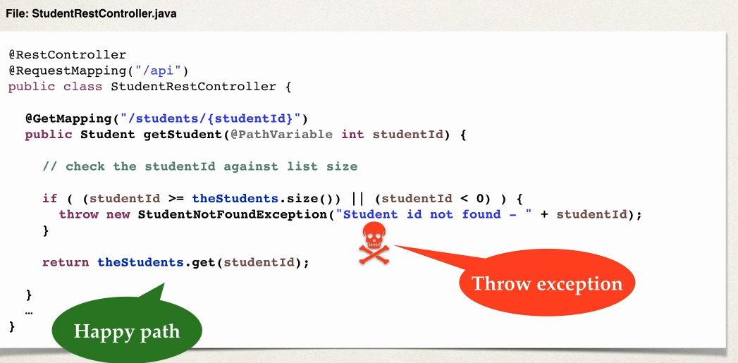

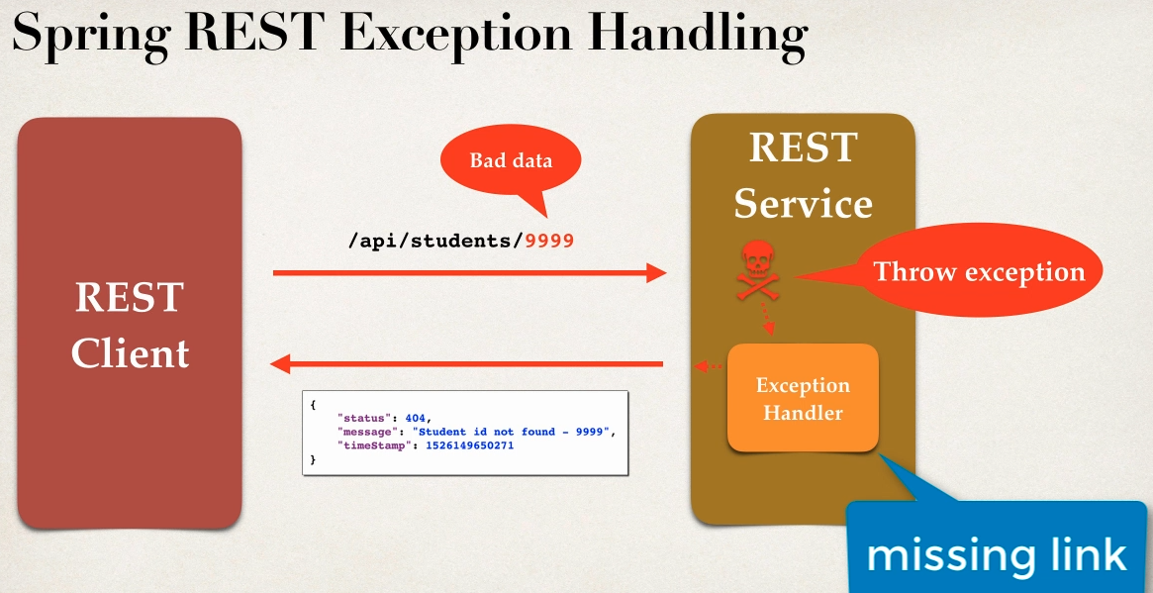

Missing link will step 4

Step 4: Add exception handler method

1 Define Exception Handler Method with @ExceptionHandler

2 Exception will return ResponseEntity

3 ResponseEntity is a wrapper for the HTTP response object

4 ResponseEntity provides fine-gained controll to specify -> HTTP status code,HTTP headers and Response Body

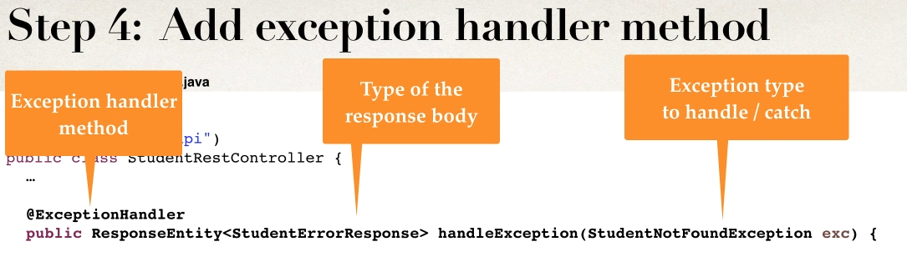

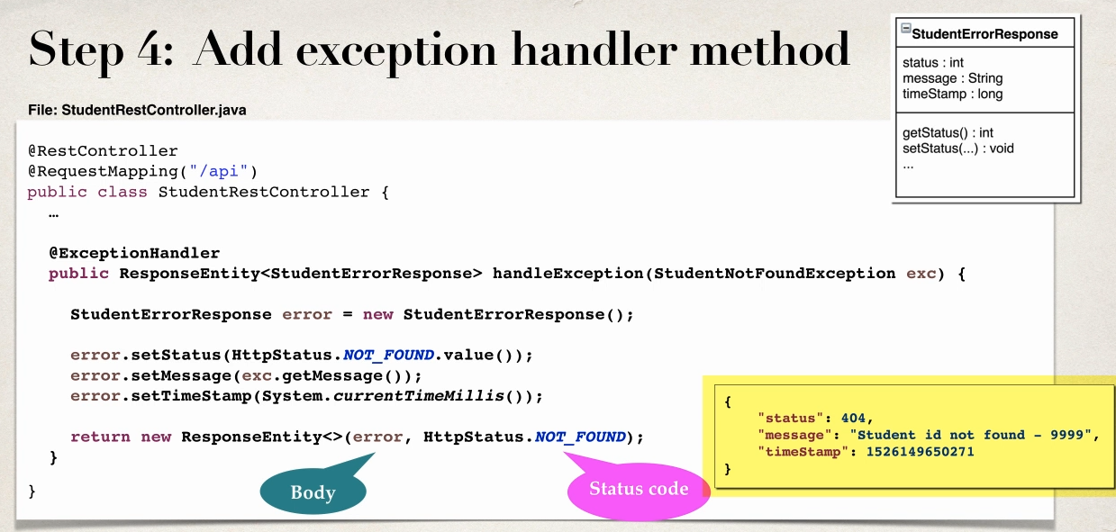

// define end point for /students/{studentId} retrun student at index along with custom Exception handling

@GetMapping("/student/data/{studentId}")

public Student getStudentData(@PathVariable int studentId)

{

// check student against list size

if(studentId>=students.size() || studentId<0)

{

throw new StudentNotFoundException("Student Id not Found- "+studentId);

}

return students.get(studentId);

}

// Add Exception handler using @ExceptionHandler

@ExceptionHandler

public ResponseEntity<StudentErrorResponse> handleException(StudentNotFoundException exe)

{

// create a StudentErrorResponse

StudentErrorResponse error=new StudentErrorResponse();

error.setStatus(HttpStatus.NOT_FOUND.value());

error.setMessage(exe.getMessage());

error.setTimeStamp(System.currentTimeMillis());

//return ResponseEntity

return new ResponseEntity<>(error,HttpStatus.NOT_FOUND);

}

<http://localhost:7777/SpringRestAPIDemo/api/student/data/-9>

This works for number data if we send string as a parameter

Will get 400 exception initaly we are getting 404 to handle 400

Modify Code to handle Generation Exception

// add another exception handler to catch any exception(catch ALL)

@ExceptionHandler

public ResponseEntity<StudentErrorResponse> genericExceptionHandling(Exception exe)

{

// create a StudentErrorResponse

StudentErrorResponse error=new StudentErrorResponse();

error.setStatus(HttpStatus.BAD_REQUEST.value());

error.setMessage(exe.getMessage());

error.setTimeStamp(System.currentTimeMillis());

//return ResponseEntity

return new ResponseEntity<>(error,HttpStatus.BAD_REQUEST);

}

Spring REST -GLOBAL EXCEPTION HANDLING

-Exception handler codes is only for the specfic REST controller

-cnt be resused by other controllers

- for large project we need Global exception handlers

-promotes reuse

-centralized exception handling

Spring @ControllerAdvice

- it is similar to interceptor /filter

- pre process request to controllers

-post process response to handle exceptions

-perfect for Global Exception

- Actuly Real time use AOP

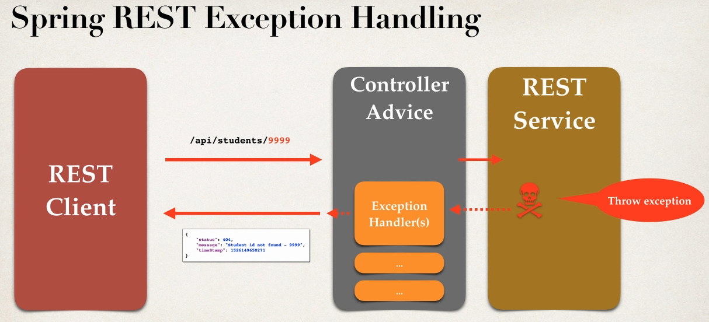

Development Process

1 create new @ControllerAdvice

2 Refactor REST SErvice -- remove Exception handling Code

2 Add Exception Handling Code to @ControllerAdvice

BEST PRACTICE USE CASE

@ControllerAdvice

public class StudentRestExceptionHandler {

@ExceptionHandler

public ResponseEntity<StudentErrorResponse> handleException(StudentNotFoundException exe) {

// create a StudentErrorResponse

StudentErrorResponse error=new StudentErrorResponse();

error.setStatus(HttpStatus.NOT_FOUND.value());

error.setMessage(exe.getMessage());

error.setTimeStamp(System.currentTimeMillis());

//return ResponseEntity

return new ResponseEntity<>(error,HttpStatus.NOT_FOUND);

}

@ExceptionHandler

public ResponseEntity<StudentErrorResponse>

genericExceptionHandling(Exception exe) { // create a StudentErrorResponse

StudentErrorResponse error=new StudentErrorResponse();

error.setStatus(HttpStatus.BAD_REQUEST.value());

error.setMessage(exe.getMessage());

error.setTimeStamp(System.currentTimeMillis());

//return ResponseEntity

return new ResponseEntity<>(error,HttpStatus.BAD_REQUEST);

}

}

Spring API Design BEST Practice

-for realtime projects who will use API

-how they will use API

-design API based on reuirement

API Design Process

1 review the API requirements

2 Identify main resource and entity

3 use http methods to assiagn action on resources

Step 1

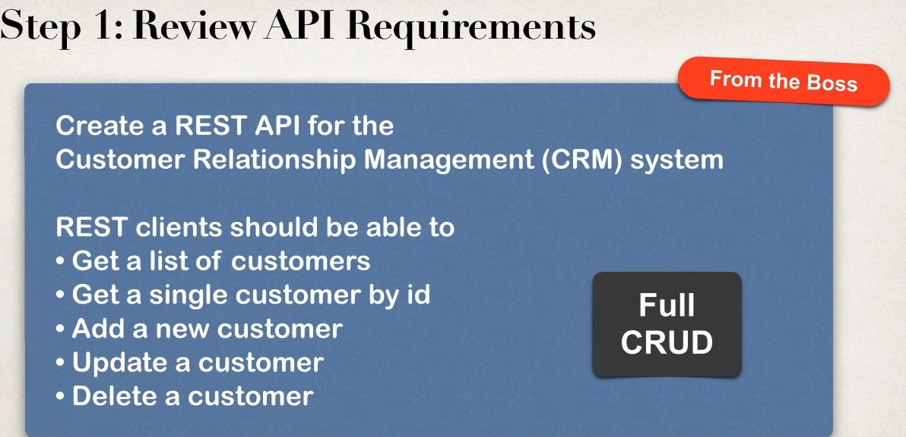

Step 2 :Identify main resources / entity look for the most prominent “noun”

-Crm project “customer”

-convention is to use plural form of entity/resources :customers

/api/customers

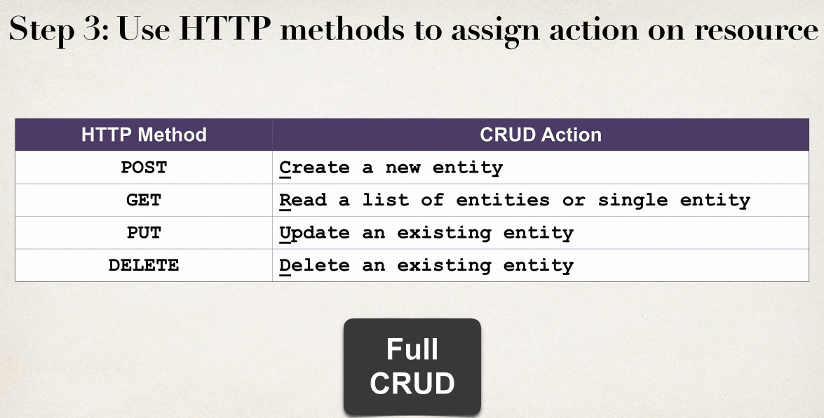

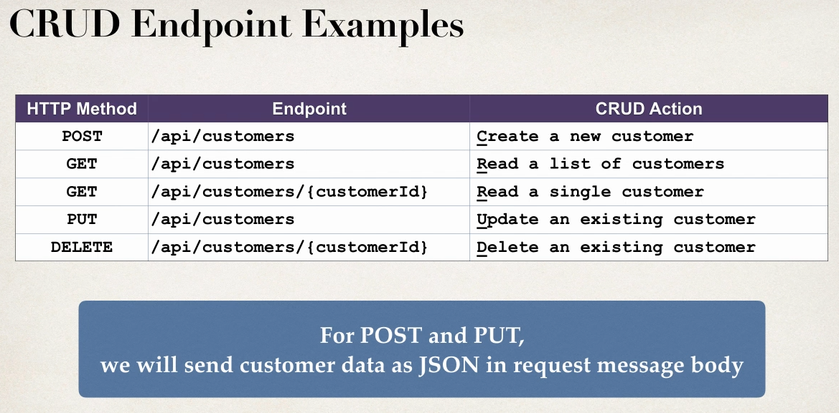

ANTI PAtterns

- dnt do this this are REST anti-patterns ,bad practice

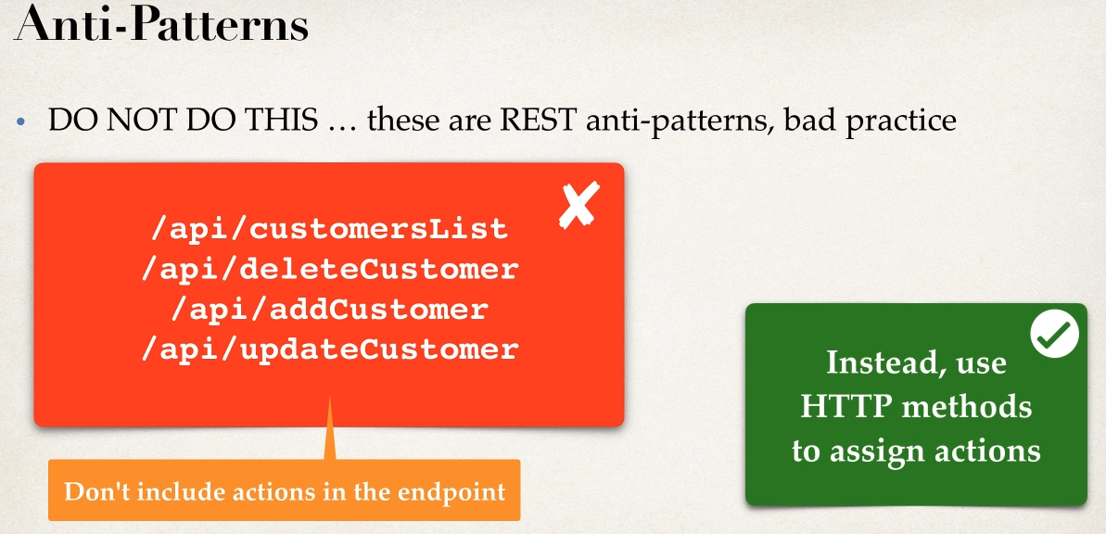

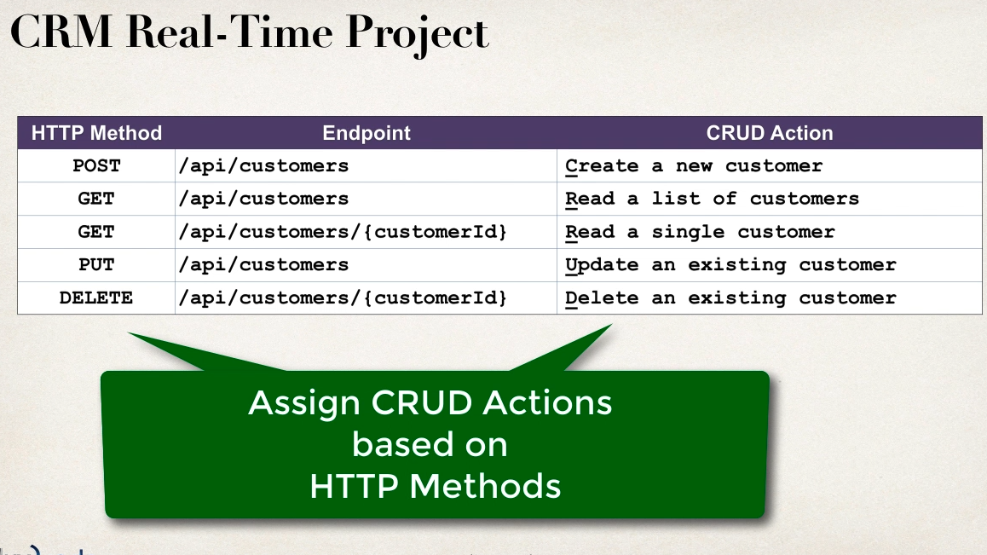

Some Real Time Project Smaple API’s

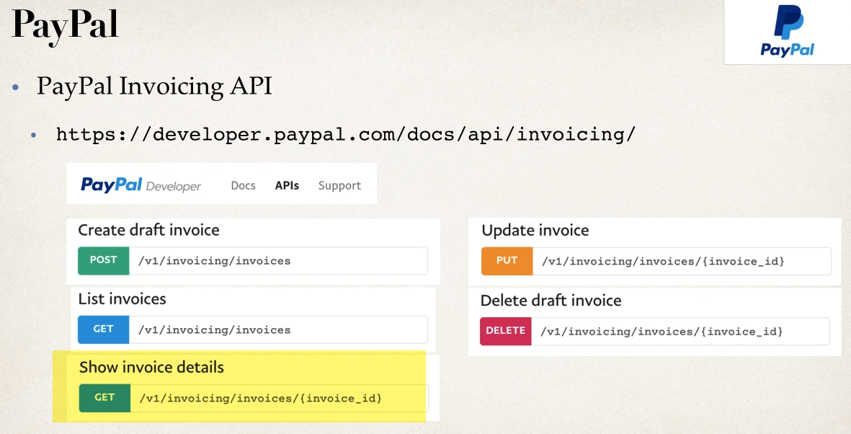

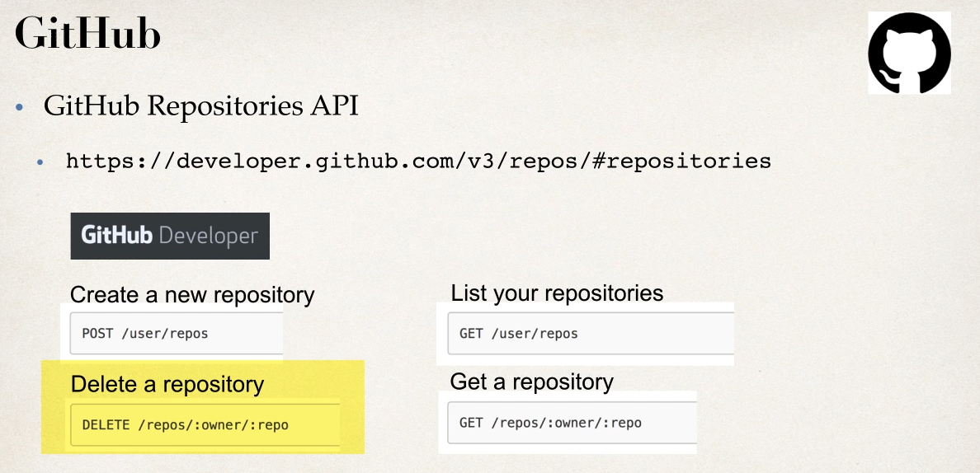

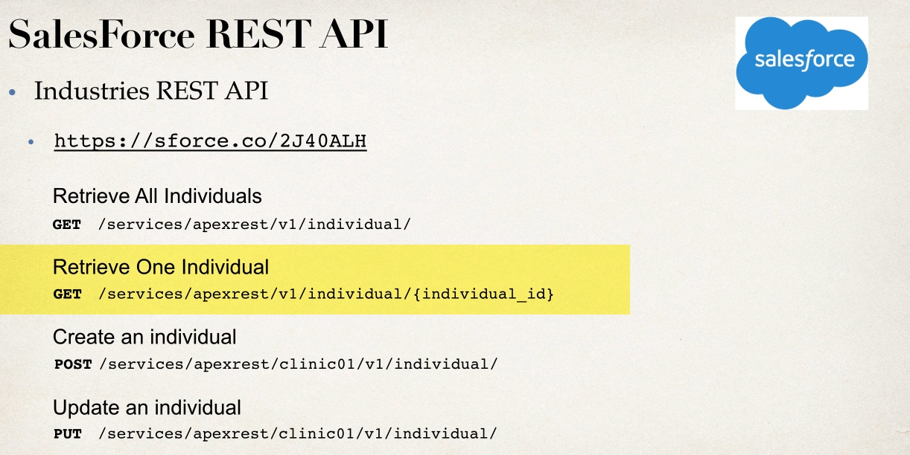

SPRING REST CRUD REAL TIME PROJECT

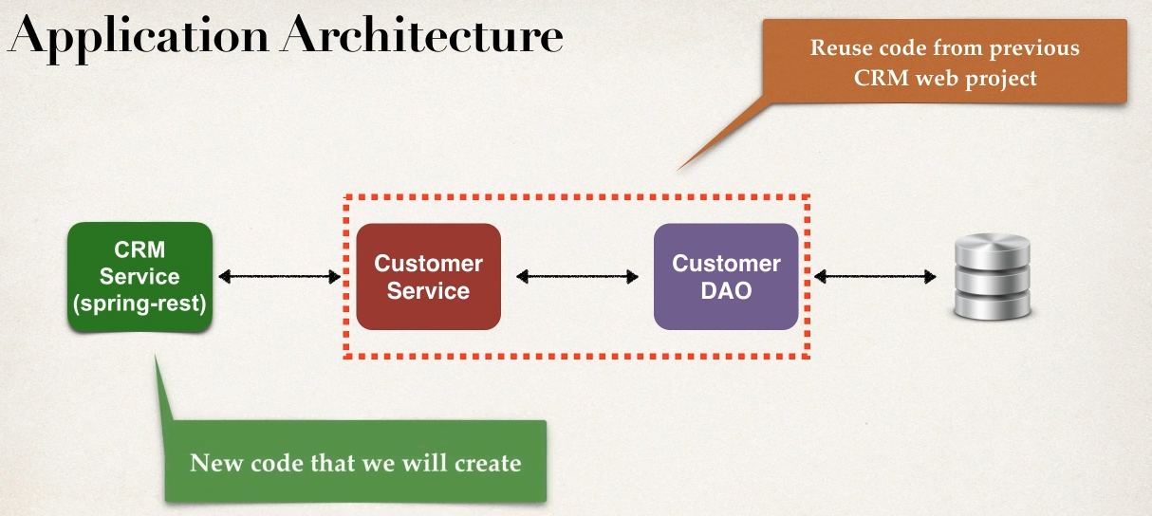

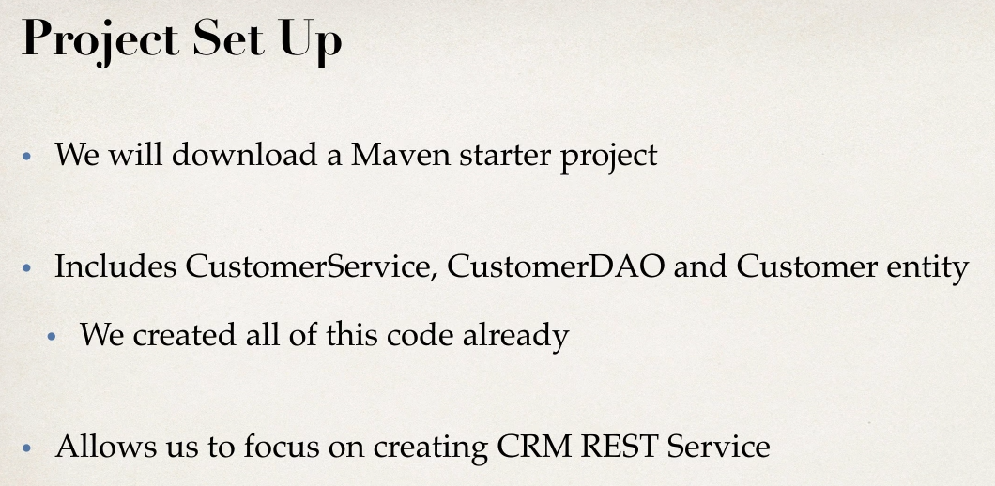

Development Process

1 Get customers

2 get Single customer by id

3 add new customer

4 Update existing customer

5 delete a customer

Code Review

1 pom.xml file

2 all java config

3 config file fr DBconnection

4 Hibernate Entity class:customer

5 DAO

6 Services

GET CONSUMERS

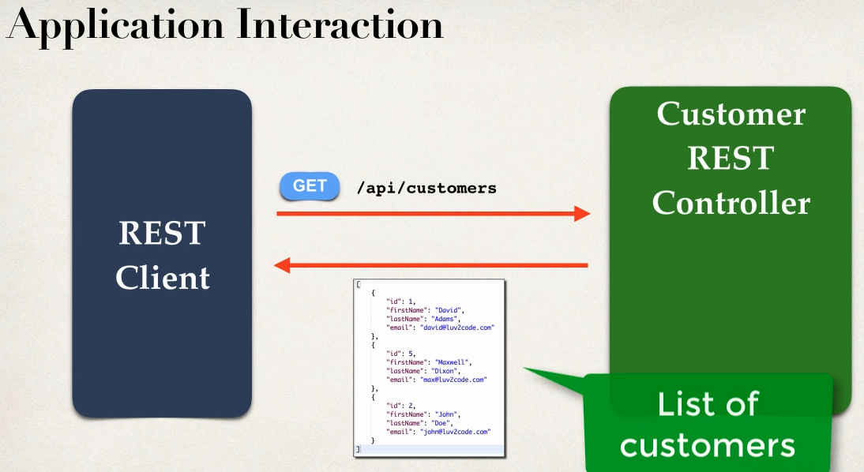

Development Process

1 create Customer REST controller

2 Autowire customer Services

3 Add mapping for GET /customers

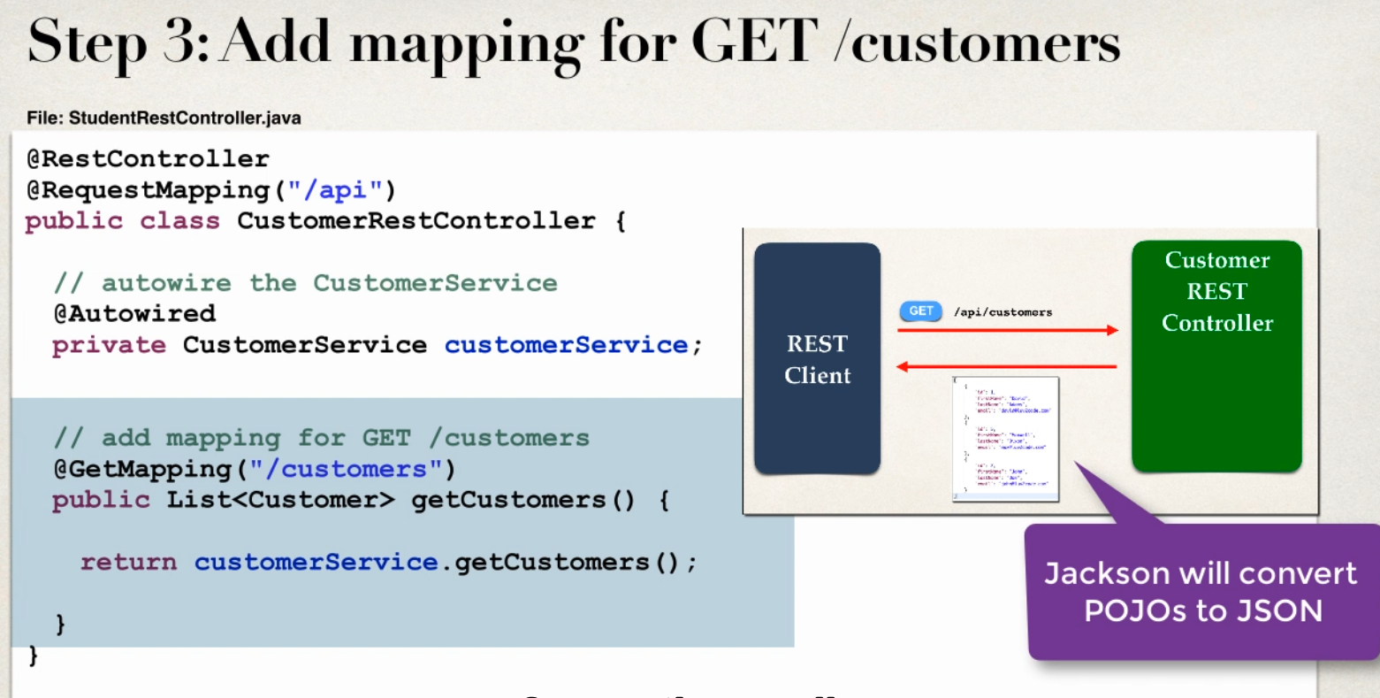

GET SINGLE RECORD from CUSTOMER based on ID

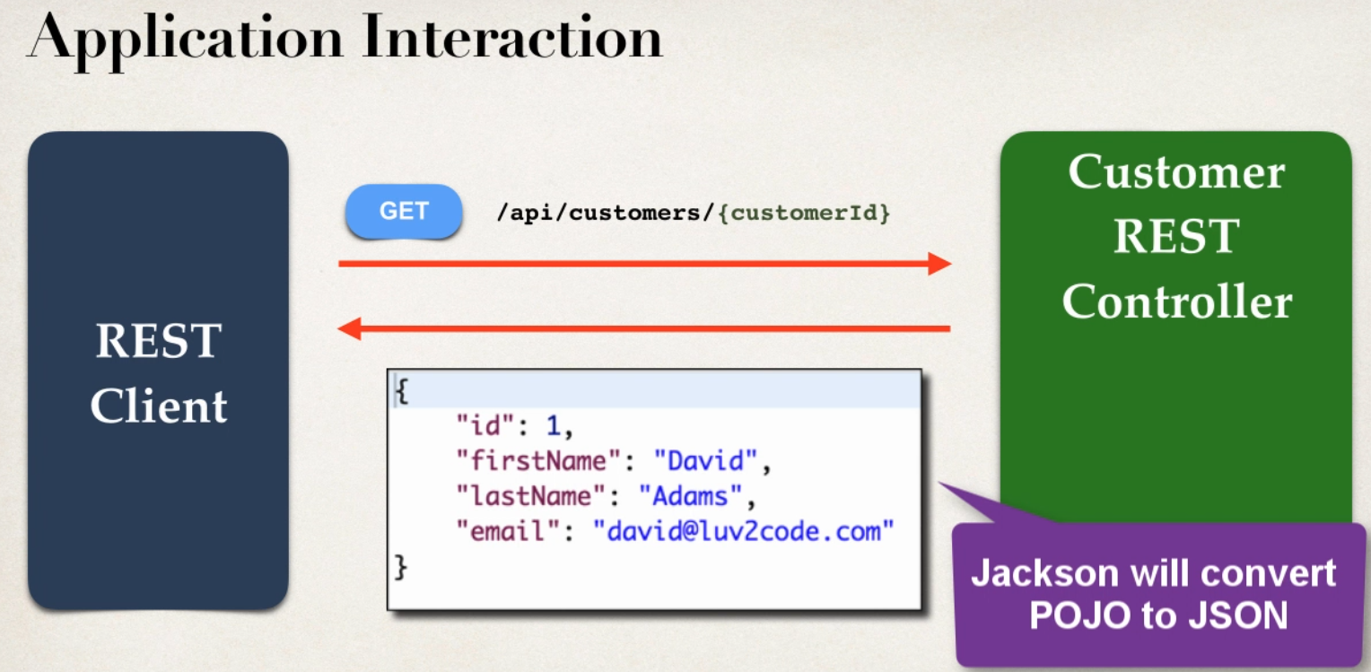

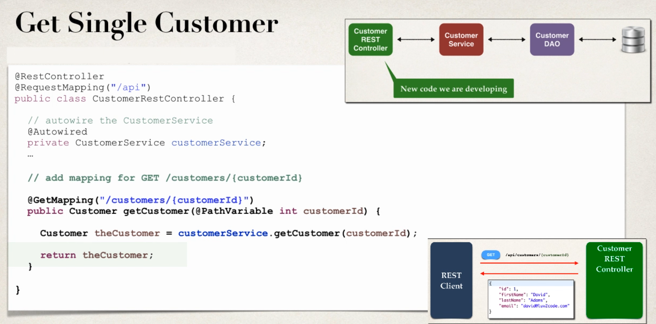

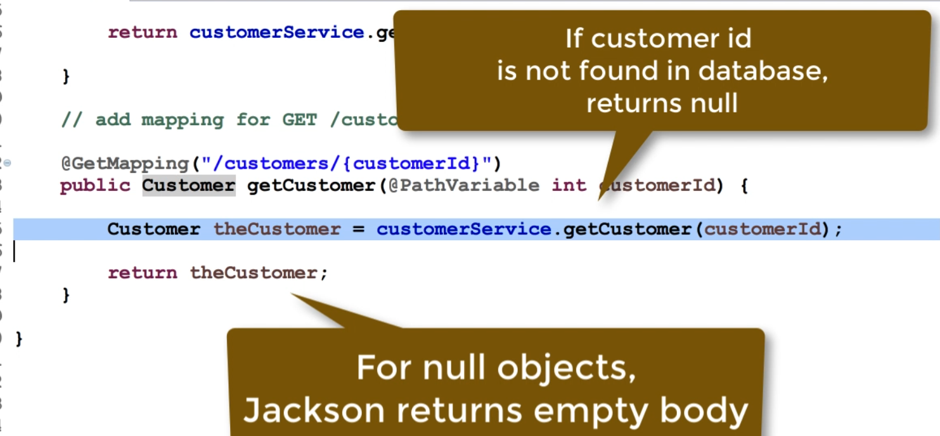

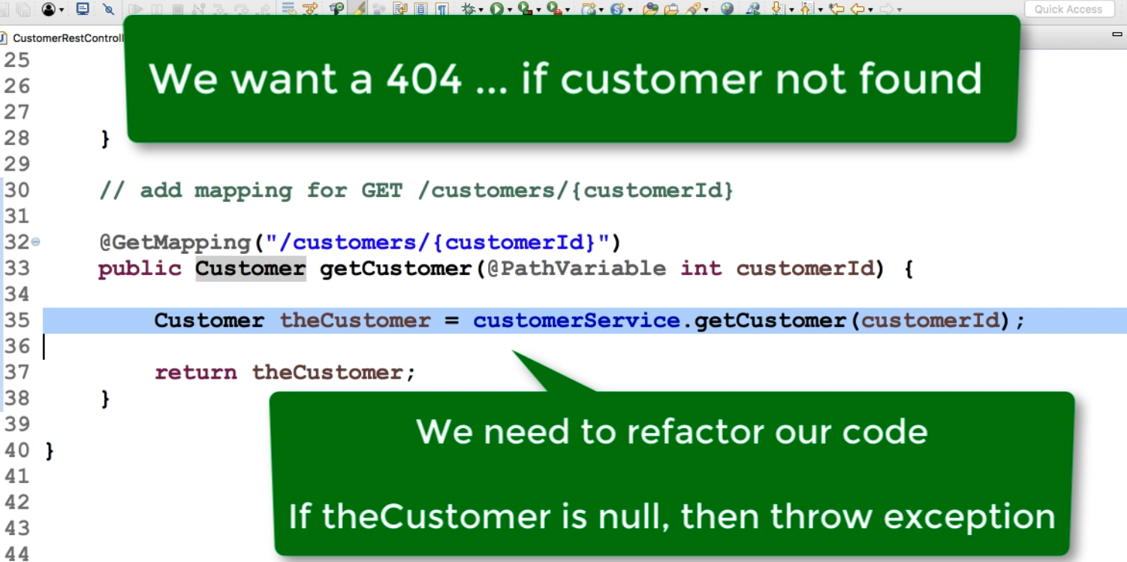

HANDLING CRM REST EXCEPTION HANDLING

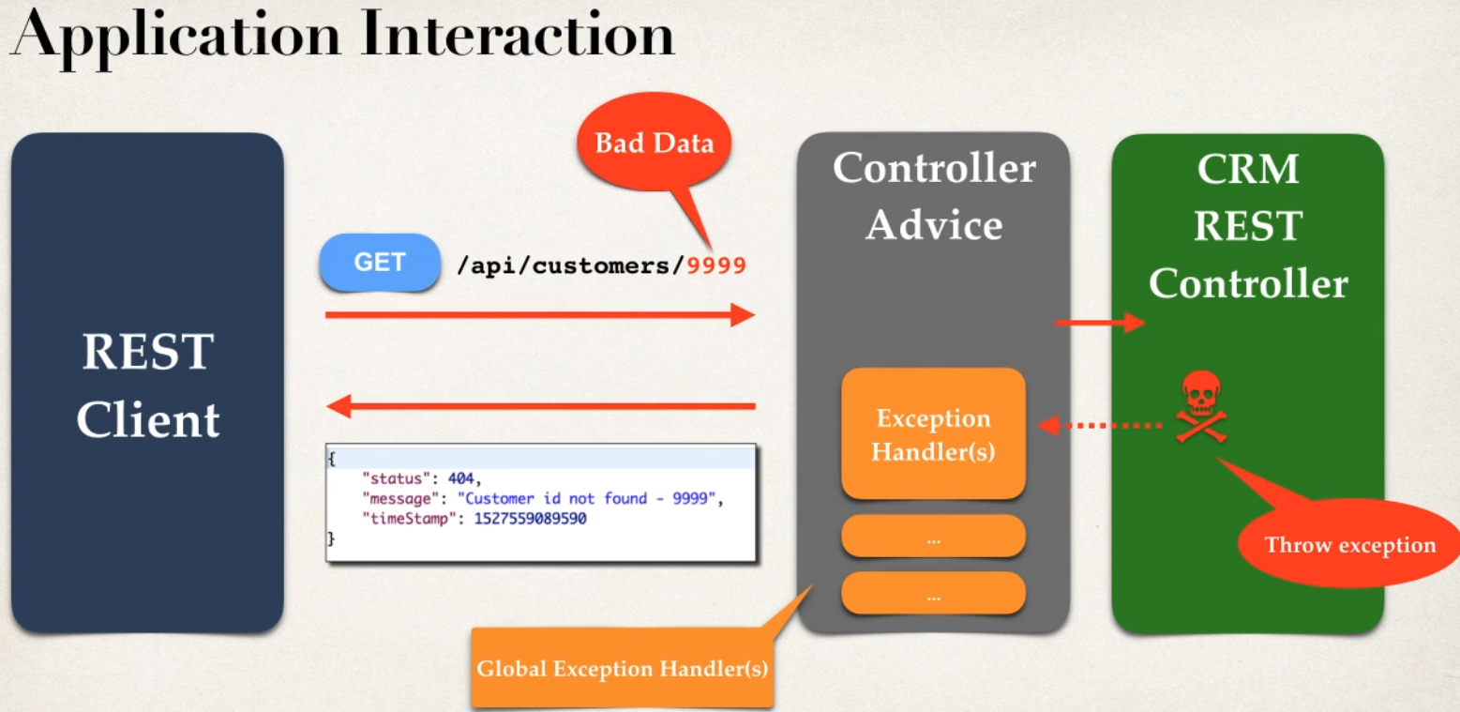

Development Process

1 create a custom error response class

2 create custom exception class

3 update REST service to thorow if customer not found

4 handle as Exception handler methods using @ExceptionHandler

Go thorugh Code

SPRING CRM ADD a CUSTOMER

Using POST http method

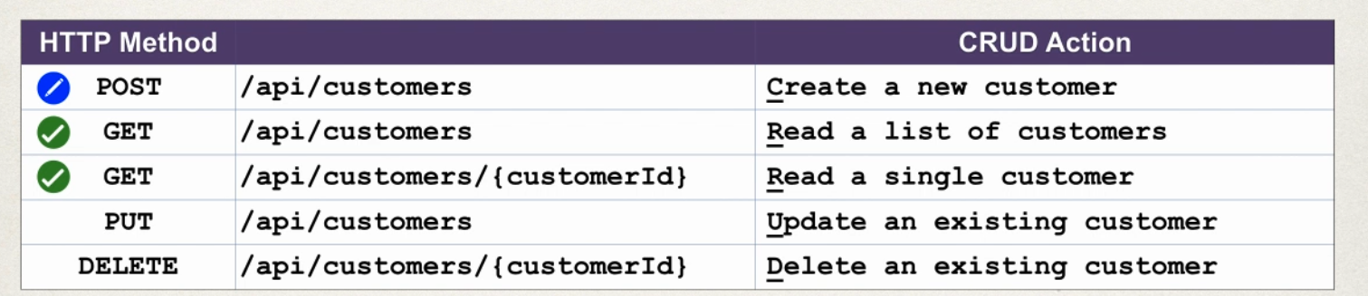

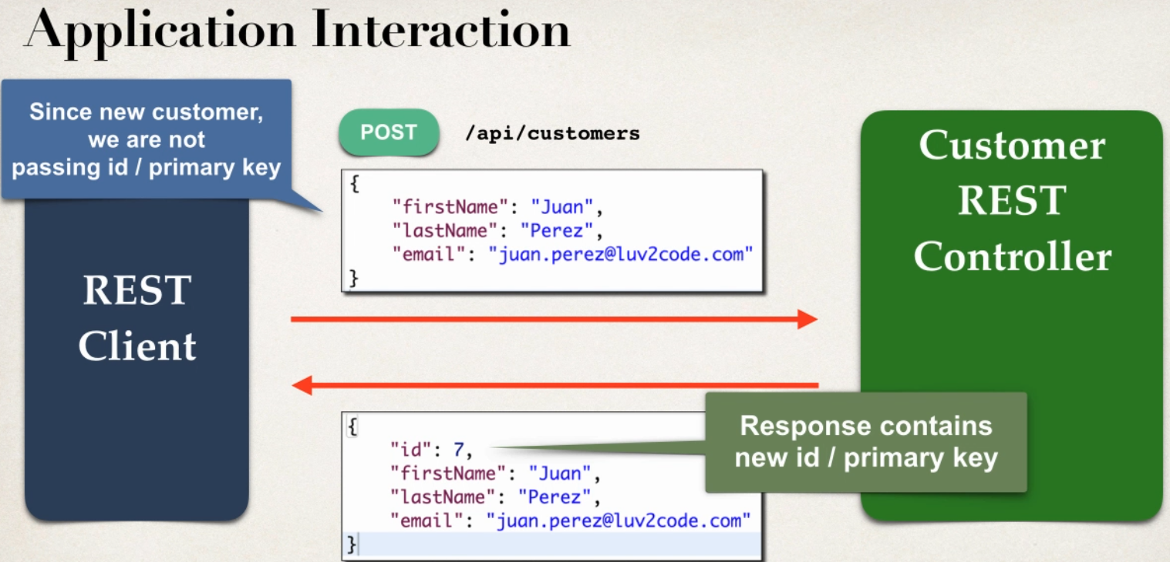

Access Request Body

- Jackson will convert Request body from JSON to POJO

- @RequestBody annotaion binds POJO to a method parameter

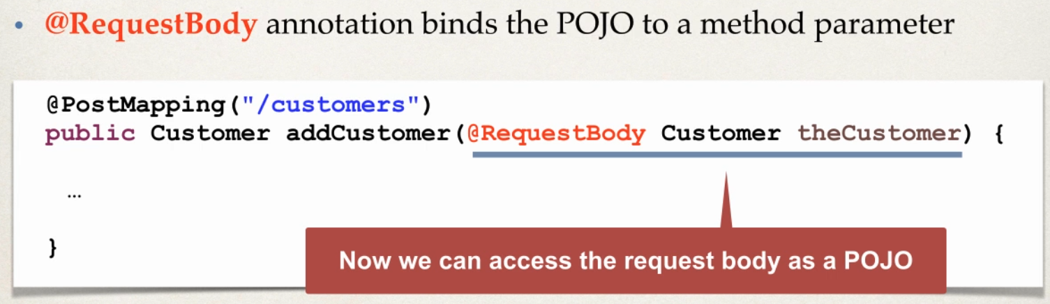

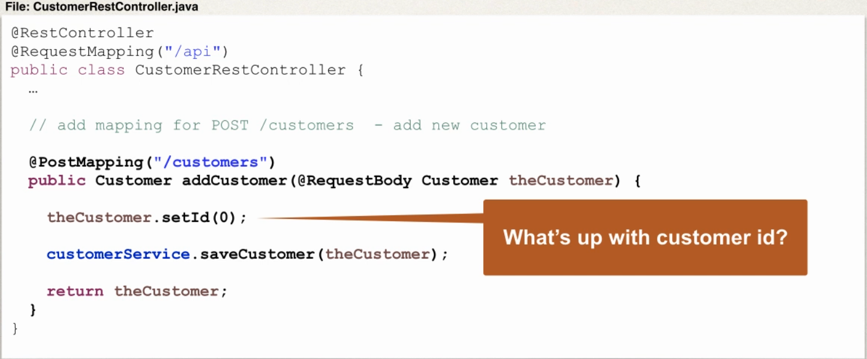

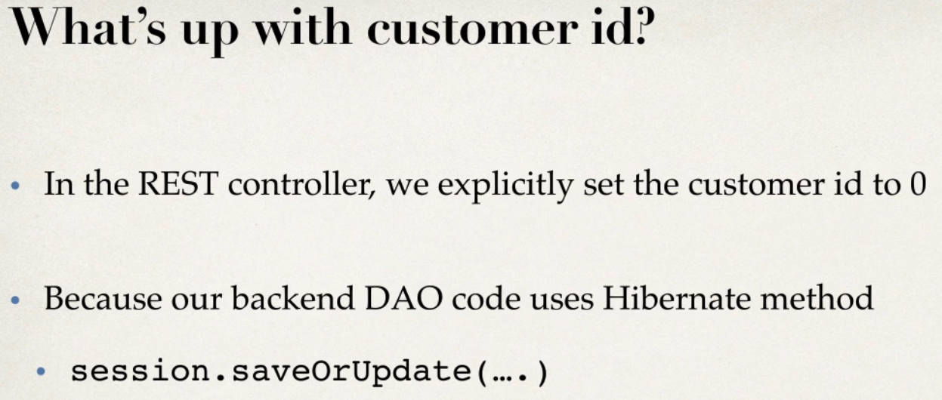

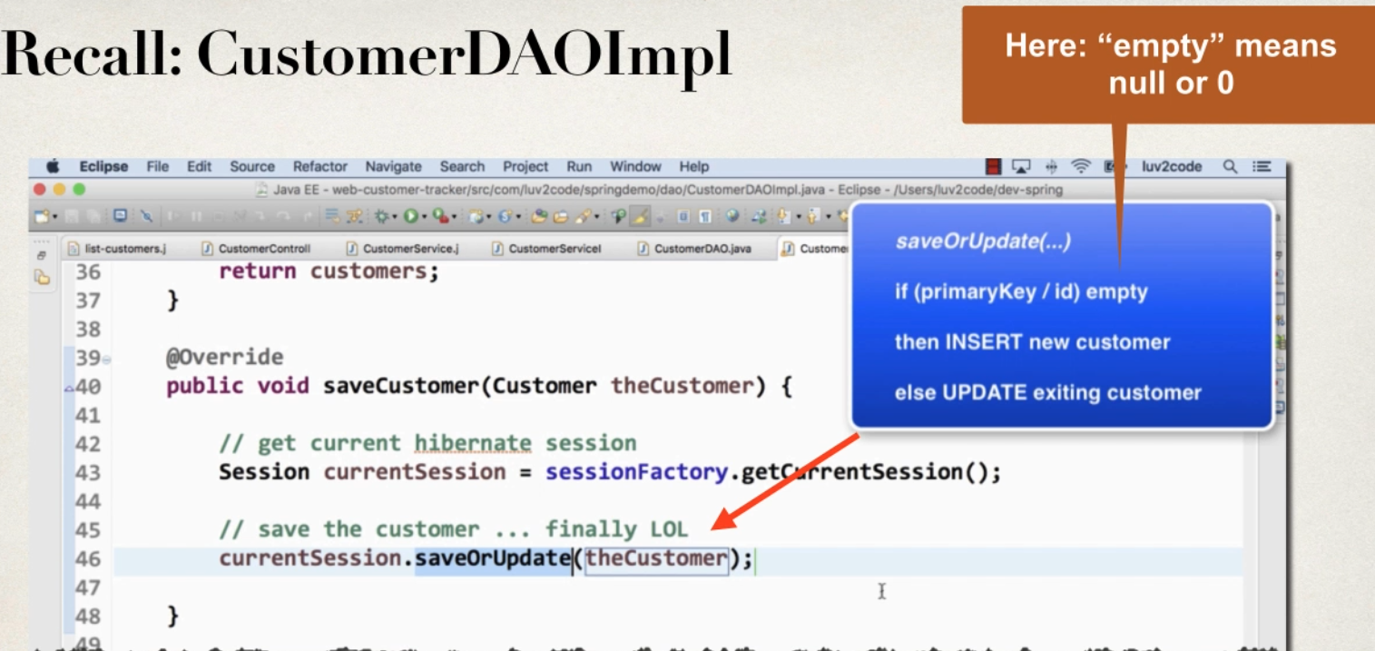

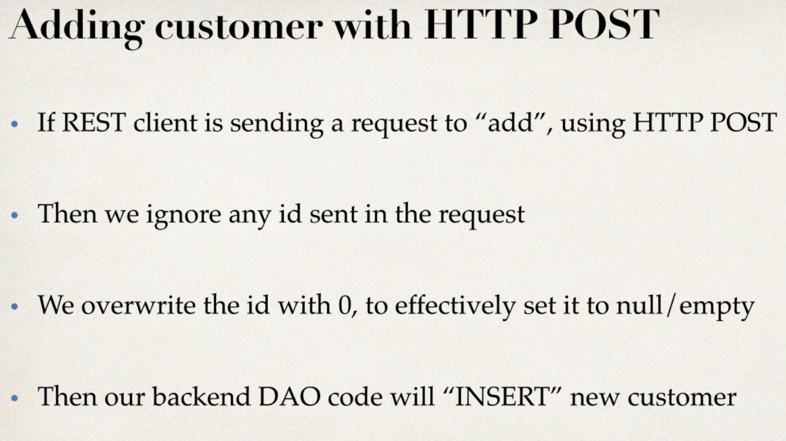

Sending JSON to Spring REST Controller

- when sending JSON Data to spring REST controller

-For controller to process JSON DATA ,need to set a HTTP request HEADER

-content-type:appliaction/json

-need to config REST client to send the correct HTTP request Header

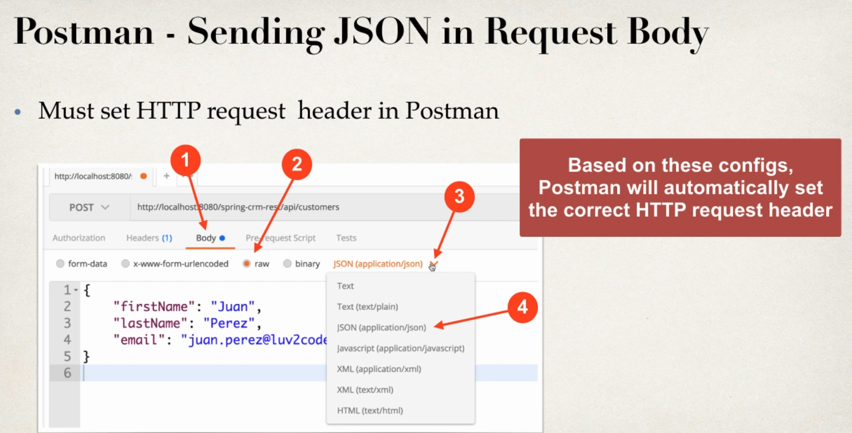

BOTH JSON works

{

"id":0,

"firstName": "sachin",

"lastName": "subramanya H S",

"email": "sachinsubramanya@bcits.in"

}

{

"firstName": "sachin",

"lastName": "subramanya H S",

"email": "sachinsubramanya@bcits.in"

}

CRM UPDATE a Customer

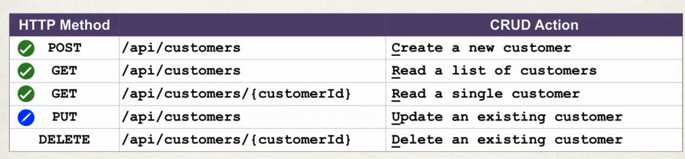

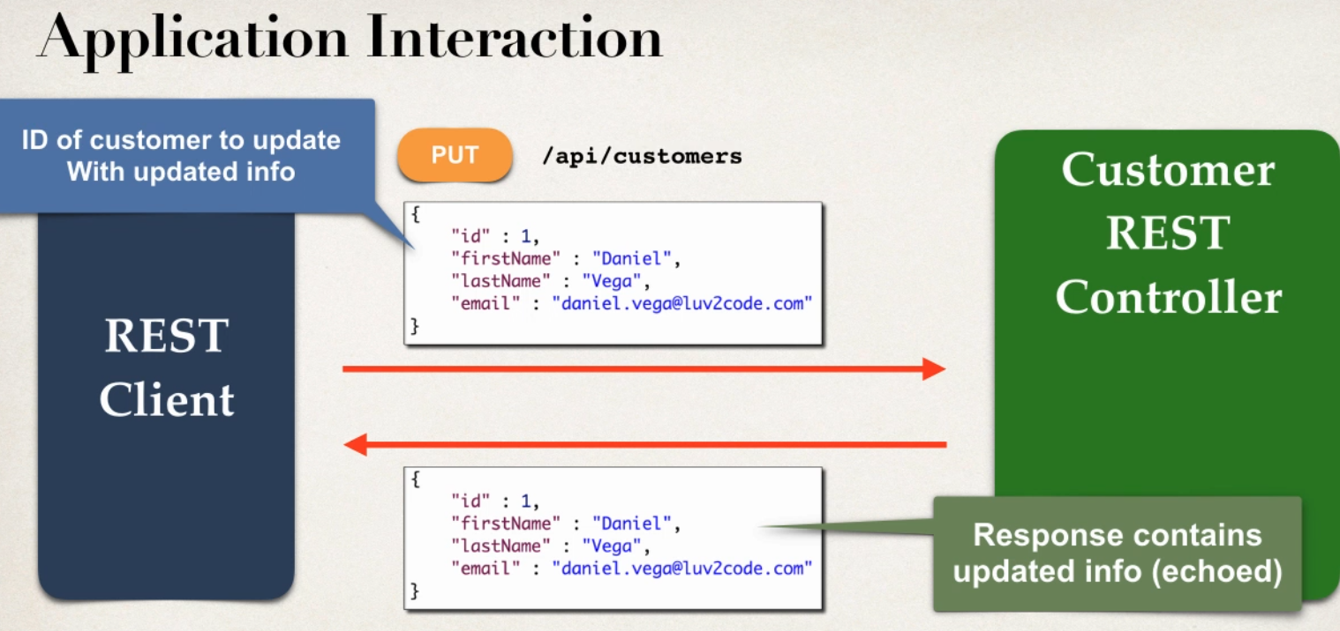

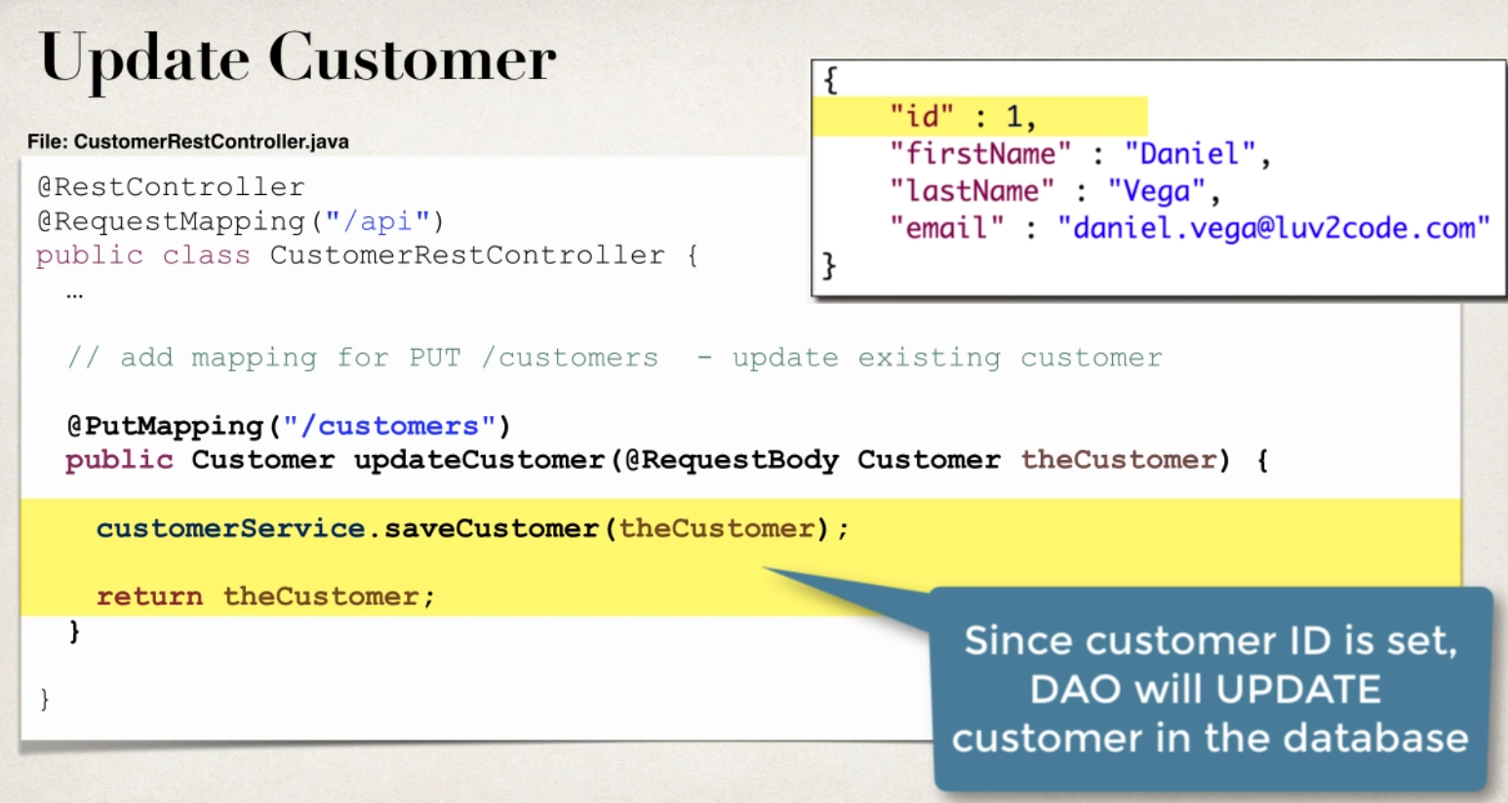

JSON works

{

"id":5,

"firstName": "Dhanvit",

"lastName": "Gowda",

"email": "diyan@gmail.com"

}

SPRING CRM DELETE A CUSTOMER

